|  |  |
| --- | --- |
|  | [Insert/Paste extra picture or delete this text] |
| **An AI Chatbot Information Support System for Water Resources Management**  **Sifiso Patience Ncube**  MSc Thesis Identifier **WSE-HI.22-13**  April 2022 | |
|  | |

|  |
| --- |
|  |
| **An AI Chatbot Information Support System for Water Resources Management** |
| Master of Science Thesis |
| by |
| **Sifiso Patience Ncube** |
| Supervisors |
| Prof. Dimitri Solomatine |
| Mentors |
| Dr. Gerald Corzo  Santiago Duarte |
| Examination Committee |
| Prof. Dimitri Solomatine  Dr. Gerald Corzo |
| This research is done for the partial fulfilment of requirements for the Master of Science degree at the  IHE Delft Institute for Water Education, Delft, the Netherlands. |
| **Delft** |
| 12/04/2022 |

|  |
| --- |
|  |

|  |
| --- |
| Although the author and IHE Delft Institute for Water Education have made every effort to ensure that the information in this thesis was correct at press time, the author and IHE Delft do not assume and hereby disclaim any liability to any party for any loss, damage, or disruption caused by errors or omissions, whether such errors or omissions result from negligence, accident, or any other cause.  © Sifiso Patience Ncube April 2022.  This work is licensed under a [Creative Commons Attribution-Non Commercial 4.0 International License](http://creativecommons.org/licenses/by-nc/4.0/) |

# Abstract

[Insert text]

# Acknowledgements

# Table of Contents

Abstract i

Acknowledgements ii

Table of Contents iv

List of Figures vii

List of Tables viii

Abbreviations ix

List of Symbols xi

Chapter 1 Introduction 1

1.1 Background 1

1.2 Statement of the Problem 2

1.2.1 Technological Problem 2

1.2.2 Water Resources Problem (Urban flooding) 3

1.3 Objectives of the Study 3

1.4 Research Questions 4

1.5 Innovation 4

1.6 Practical Value 4

Chapter 2 Literature Review 6

2.1 Urban Floods 6

2.2 Chatbot Technology 9

2.2.1 The History of Chatbots 10

2.2.2 Basic Functions in Chatbots 10

2.3 Natural Language Processing Algorithms 11

2.3.1 Preprocessing Techniques in NLP 11

2.3.2 Vectorisation in NLP 17

2.3.3 Word Embeddings in NLP 17

2.4 Dialogflow 17

2.4.1 Intents 17

2.4.2 Context 17

2.5 Webhooks 17

2.5.1 Flask 17

2.5.2 Bottle 17

2.6 Web Design 18

2.6.1 HTML 18

2.6.2 Cascading Style Sheet(CSS) 18

2.7 EPA SWMM 19

2.8 Review of Related Work 21

Chapter 3 Study Area 23

3.1 General Description 23

3.2 Flooding Trends and Awareness 26

3.3 The Urban Drainage Network in Ha Dong 26

Chapter 4 Methodology 29

4.1 NLP Algorithms 29

4.1.1 Tokenization 29

4.1.2 Byte Pair Encoding 29

4.1.3 Stemming 29

4.1.4 Lemmatization 29

4.2 Chatbot Development Using Dialogflow 30

4.2.1 Dialogflow Appointment Scheduler 30

4.2.2 Dialogflow: SWMMBot 33

4.3 Webhooks 33

4.4 Webpage design 33

4.4.1 Hyper-Text Mark-up Language (HTML) 33

4.4.2 Cascading Style Sheet (CSS) 34

4.5 EPA SWMM Model Setup 35

Chapter 5 Data Extraction from EPA SWMM 46

5.1 Python Functions for Data Extraction from EPA SWMM 46

Chapter 6 Results 50

6.1 Chatbot 50

6.1.1 Appointment Scheduler 50

6.1.2 SWMMBot 51

6.2 Web Page 51

6.3 Implementation: Chatbot Pilot Test 51

Chapter 7 Conclusions and Recommendations 52

7.1 Conclusions 52

7.2 Recommendations 52

References 52

Appendices 54

Appendix A. - Research Ethics Declaration Form 55

References 56

# List of Figures

Figure 1: Flood displacement risk by region 7

Figure 2:Synthesis assessment of observed change in heavy precipitation and confidence in human contribution to the observed changes in the world’s regions. Source:(IPCC, 2021) 8

Figure 3:Major and minor flow interactions during an extreme event Adapted from (Schmitt, et al., 2004, Ellis, et al., 2009) 8

Figure 4: Natural Language Processing Pipeline 11

Figure 5: Tokenization 12

Figure 6: An Illustration of Word-Based Tokenization 13

Figure 7: Character-Based Tokenization 14

Figure 8: Subword Tokenization 14

Figure 9: Lemmatization vs Stemming 16

Figure 11 Inse dolore magna aliquam 22

Figure 13: Annual rainfall 1975-2018 24

Figure 14:Do Lo, Hanoi, Vietnam 25

Figure 15:Landcover in Do Lo, Yen Nghia, Ha Dong Source:(Do, 2021) 26

Figure 16: Drainage system in Do Lo, Yen Nghia, Ha Dong 27

Figure 17: Dialogflow Console 30

Figure 18: Sample responses for the Welcome and Fallback Intents 31

Figure 19: Schedule Appointment Intent Set-up 32

# List of Tables

Table 1 Dolor sit amet, consectetuer adipiscing elit 22

# Abbreviations

[Optional]

# List of Symbols

[Optional]

1. Introduction

The purpose of research has mostly been to build on available knowledge to enhance the way people live. This chapter, therefore, provides the context that motivates this research thesis mainly focusing on issues pertaining to urban flood management, challenges faced in abstracting data from modelling systems and possible solutions to these challenges. The set objectives to address these challenges are also discussed together with the research questions that arise. In addition, innovative aspects of the study are outlined together with the practical value of the research in water resources management.

## Background

Urban floods, like numerous other water-related disasters are on the increase globally, due to an increase in extreme precipitation as a result of variations and changes in climate as reported by the Intergovernmental Panel on Climate Change IPCC (2021). On the other hand, as of 2007, global trends show that 54% of the population is now based in urban areas (Sörensen, et al., 2016). Consequently, urban development will continue to rise in response to this migration to provide housing and other necessary infrastructure. The resulting outcome is more impervious surfaces, less infiltration leading to shorter times of concentration and higher peak flows when it rains. The resulting increased volumes of stormwater consequently put a strain on the drainage system which has to convey these volumes within a shorter time frame. Moreover, in cities with Combined Sewer Systems (CSS), a continued increase in the urban population results in more wastewater being produced, subsequently increasing the strain on the drainage systems whose capacity would thus have been exceeded. The drainage systems may then in turn surcharge and eventually outflow, causing flooding which results in the devastation of properties, disruption of economic activities, and even loss of lives (Najibi and Devineni, 2017).

To better understand these flood disasters, decision support and modelling technologies are used. These allow for the handling of vast amounts of e.g. climatic data for flood forecasts and the transmission of the obtained analysis results to decision-makers. They thus provide answers to issues at a cheaper cost and the use of computers allows for multiple tasks to be performed at a given time, for information to be processed at faster speeds and the delivery of accurate and reliable results. To harness the benefits that come with computer use, in most urban areas, simulation models like the Environmental Protection Agency’s Storm Water Management Model (EPA SWMM), MIKE-Urban, and SOBEK-Urban, among others, have been used widely for decision support. They allow for the design, planning and management of urban drainage systems.

One particularly important feature, in view of flooding, is the ability of these modelling systems to show locations in the drainage network where manholes are flooded, the flooded area and the depth of flooding. This information is critical for flood awareness creation since if disseminated timely, it can assist the affected population to make decisions on the proper course of action to take in times of flooding. The main challenge, however, is that there is no direct access to these modelling results by the general population. Chatbots offer a solution to this gap in information dissemination.

Chatbots are computer programs (agents) that use Artificial Intelligence AI-trained natural language to simulate human-computer interaction (Ranavare and Kamath, 2020) as one would with another human being. They make it possible for people to access modelling results without having to run the simulation model themselves. The widespread use of chatbot results, firstly from the fact that they allow for the transfer of information through normal conversation at the user’s own pace and at a rate at which they can understand and assimilate it. Secondly, chatbots provide instant answers and support. In addition to this, they provide ubiquitous (round-the-clock) access to information which would be of great advantage for flood awareness creation amongst the general public.

Chatbots fulfill the user’s request, which can either be a text or voice message, by matching the user’s intent to a predefined response (Dahiya, 2017). The intent is the objective of the user, that is, what they want to extract from the system or what they want to know as they type their question(s). As various users would ask the same question in different ways, a ‘bank’ of possible questions is created and then the Chatbot is trained using artificial intelligence to match the queries to their respective responses (Ranavare and Kamath, 2020, Setiawan, et al., 2020). For it to be deemed successful, the Chatbot has to understand the user’s request to a point where it can match it with the required response, a process called parsing the intent. To be able to simulate situations that change with time, i.e. dynamic content, the chatbot has to connect to a webhook, that is, “an HTTP (Hypertext Transfer Protocol) request by which real-time information is provided to other applications”(Google, 2021, 25 Oct). Due to the numerous benefits brought about by chatbots their use is evident in various fields such as banking, marketing, agriculture, flood awareness and water management, among others.

## Statement of the Problem

### Technological Problem

Floods, by nature, bring with them financial, health and psychological impacts most of which are felt even long after the flooding ceases. To help alleviate these impacts, advancements in technology have brought with them improvements in flood risk and water resources management where a variety of modeling systems are now used to assist and inform decision-making. However, information obtained from these modelling systems is not easily accessible to the affected population. There is, therefore, a need to develop tools that will improve access to flooding information in an easy, straightforward and fast way, especially for the general public so that they are better informed about the flooding situation in their respective locations.

While modelling systems, have been, and will continue to prove priceless as decision support tools in water and flood risk management, the fundamental difficulty with these systems is that they are complex to use. Prior knowledge of the system's navigation procedure, that is, the various steps involved in obtaining the desired results is required. In addition, their user interfaces usually have numerous editors where different data should be input for the model to run appropriately and give accurate results. This makes these systems difficult for the general public or those unskilled in modelling to use. Gironás, et al. (2010) and Irvine, et al. (2016) also asserts that some of the modeling systems can be too cumbersome, consequently requiring the user to undergo some training. Furthermore, Lemos, et al. (2010) noted a positive correlation between the use of technical knowledge and whether or not it is understandable. This then implies that as the modeling system processes become less understandable its use also declines. In addition, the language used in the modelling system can also be a limitation on its use. This then generally makes these systems inaccessible to untrained civilians.

Nonetheless, advancements in Artificial Intelligence have enabled easier access to information through the development of chatbots. These provide a simplified solution that can assist in bringing modelling system results to the affected population. They allow for the direct extraction of information from the modelling systems, and instant feedback to the user in small portions that are easy to understand. Chatbot information systems have been used in numerous sectors, for example in aquaculture (Al Rasyid, et al., 2020); agriculture (Mostaco, et al., 2018); flood awareness (Tsai, et al., 2019, Okon, 2021), water supply (Setiawan, et al., 2020) and in the banking and marketing sector. Nevertheless, the adoption of the chatbot technology in water and flood risk management is still minimal and therefore needs improvement.

### Water Resources Problem (Urban flooding)

Most urban areas with combined sewer systems are prone to flooding during extreme rainfall events. This is because traditional grey infrastructure designs are now incapable of coping with increased stormwater flows resulting from high-intensity rainfall events (Salinas-Rodriguez, et al., 2018). High flows then lead to surcharging of the drainage pipes as the flow in the network becomes pressurized (Schmitt, et al., 2004). Extended surcharging may lead to the bursting of manholes and flooding as water outflows from the system. Furthermore, surcharging of the sewer network also hinders the surface water from entering the sewer network (Schmitt, et al., 2004) leading to increased ponding of the water above the ground surface. Flooding resulting from this failure of the drainage network leads to damages to property, disruption of transport services and environmental and health impacts which in turn lead to other indirect socio-economic effects (Cembrano, 2004). The objectives of the study are therefore outlined in following sections.

## Objectives of the Study

The **main** aim of the study is to explore the technological tools and develop a prototype of a Chatbot urban flood information system.

To achieve the main goal, the **specific** objectives are:

* To analyze and learn the chatbot AI algorithms.
* To design a database of intents and actions of the information system. Develop a word bank of possible terminologies used by users in dialogue when asking questions related to urban drainage and flooding.
* To analyze the flood information system in SWMM (variables, runtimes, etc) and how to connect these using Python.
* To develop algorithms (build a library of functions) that will connect(couple) the Chatbot and SWWM.
* To test and validate the results of the model runs.

## Research Questions

* What are the different purposes of running a SWMM model, i.e. what possible outcomes are the users searching for when running the model?
* What properties (variables, runtimes) in SWMM are important in flood analysis?
* How can we connect(couple) the Chatbot and SWWM using Python? How can these technologies be integrated so as to have a water resources information system?
* Is the Chatbot able to match the users’ requests with the respective responses? Is the chatbot capable of extracting information from a modelling system, running the model, changing a parameter and providing answers from the model run?
* Are the results from the model runs accurate? What are the limitations, advantages and disadvantages of this technology?

## Innovation

The innovations of the research include:

* Developing an AI-trained Chatbot to provide comprehensible information and support as a tool for creating resilience to flooding in urban areas.
* Developing a Chatbot coupled with an urban drainage modelling system to assess flooding.
* Application of AI chatbots in the management of urban drainage systems. This will enhance the speed with which information is extracted for more efficient flood management.

## Practical Value

* Development of an intelligent system to provide direct sources of answers for flood management awareness in urban areas.
* Easy extraction of model results through asking the Chatbot questions to determine low and high flows in urban drainage systems.
* Development of a decision support information system for use by citizens, and to a lesser extent, decision-makers and water managers.

|  |
| --- |
| Firstly, the chapter introduced basic concepts on Chatbots. The processes involved from the time a user types their request until they receive a response from the Chatbot were discussed. Secondly, a discussion of flooding in urban areas in light of extreme rainfall events resulting from changes in climate and growth in the urban population was done. Together with this, a description of how flooding occurs resulting from interactions between major and minor flows was included. Following that, a statement problem was defined together with the objectives and research questions to address these problems. Finally, the innovation of the study and the practical value were expounded on. |

1. Literature Review

For every study, a review of literature is necessary to learn from other researchers’ successes and failures and thus identify any gaps that need further research. This chapter, therefore, outlines the literature reviewed to better understand urban flooding, the chatbot technology, the Dialogflow platform, the EPA SWMM model and web development among others. The chapter expounds on the ideas introduced in Chapter 1 and sets the foundation for the methodology and results outlined in the proceeding chapters.

## Urban Floods

The catastrophic impacts of floods are felt annually in various areas across the globe. The Dartmouth Flood Observatory reports the death of more than 500000 people and the displacement of more than 650 million during the period 1985-2014. Economic damages during the same period are estimated to be around US$800 billion making floods one of the costliest of natural disasters on the globe (Kocornik-Mina, et al., 2020). In Europe alone, direct flood damages between 2000 and 2012 were estimated to have been around 4.9 billion Euros per annum (Sörensen, et al., 2016). In the year 2021, European flood damages are estimated to have been around 10 billion Euros. Focusing on flood impacts on humans, the Internal Displacement Monitoring Centre IDMC (2019) 2019, reports that annually, on average, floods leave around 17 million people at risk of displacement and 80% of these are urban or peri-urban dwellers. Figure 1 shows the proportion of the number of people at risk of being displaced by floods annually per region, illustrating that a majority of these live in urban areas.

The occurrence of floods in urban areas is exacerbated firstly, by the increase in paved surfaces as construction increases to cater for the continuous increase in urban migration. Sörensen, et al. (2016) highlight that a greater percentage (54%) of the world population now lives in urban areas and this value is expected to continue to rise. Therefore, consequently, urban development continues to rise in response to this increase in urban migration so as to provide housing and other necessary infrastructure (García, et al., 2015). This increased development leads to more paved surfaces which hinder infiltration leading to reduced times of concentration and greater peak flows when it rains (Eckart, et al., 2018) and thereby resulting in more flooding.

Secondly, increased flooding results from the intensification and frequency of extreme precipitation (Salinas-Rodriguez, et al., 2018, IPCC, 2021). The IPCC report confirms the increase in heavy precipitation in most countries where data is available as illustrated in Figure 2.

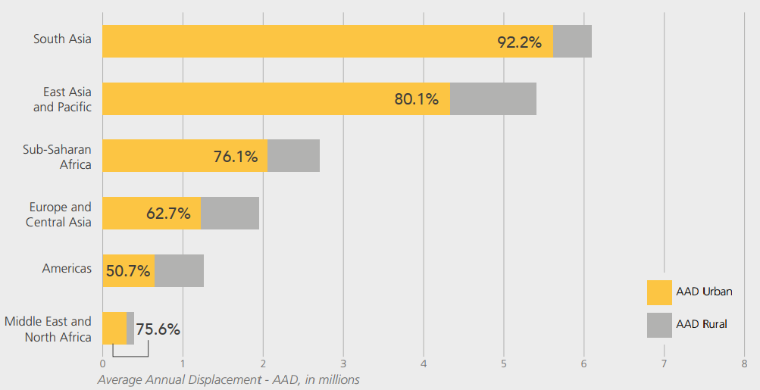

Figure 1: Flood displacement risk by region

This increase in the frequency of heavy precipitation will consequently translate to more recurrent flooding, the impact of which will be felt in urban areas which are usually developed on flood plains. The Global Disaster Assessment Report also concurs with these other findings stating a 33% increase in the frequency of flood events in 2020 compared to the mean for the previous 10 years. The resulting increased volumes of stormwater flowing at rapid speed consequently put a strain on the drainage system which has to convey these volumes within a shorter time frame. Moreover, in cities with Combined Sewer Systems, a continued increase in the urban population implies that more wastewater is produced, subsequently increasing the strain on the drainage systems as their capacity is exceeded (García, et al., 2015). As a result, these systems, which normally flow under gravity, may surcharge and eventually outflow, causing flooding of streets and buildings. A layout of such a system is illustrated in Figure 3 showing an overflow from the manhole resulting in flooding. These floods usually result in the devastation of properties, disruption of economic activities, and even loss of lives as discussed above (Najibi and Devineni, 2017).

The Global Disaster Assessment Report of 2020 reports that in 2020 flood-related deaths were 7% less than the historical average (AoDREM, 2020). This may be attributed to advancements in technology that allow for better forecasting and information dissemination through early warning systems and improved flood risk management. To enhance flood risk management modelling technologies and decision support systems are used to better understand the flooding phenomena. These add value to raw data by providing additional vital, synthesized information.

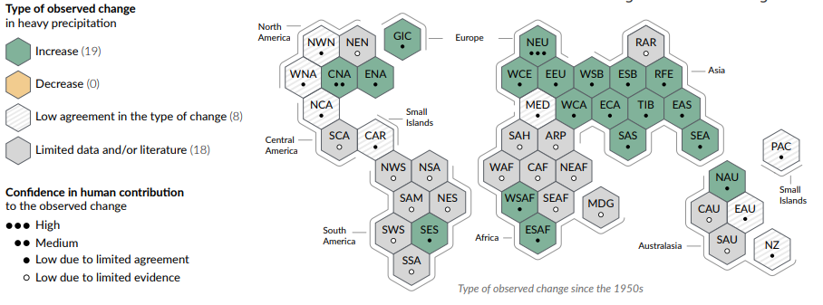

Figure 2:Synthesis assessment of observed change in heavy precipitation and confidence in human contribution to the observed changes in the world’s regions. Source:(IPCC, 2021)

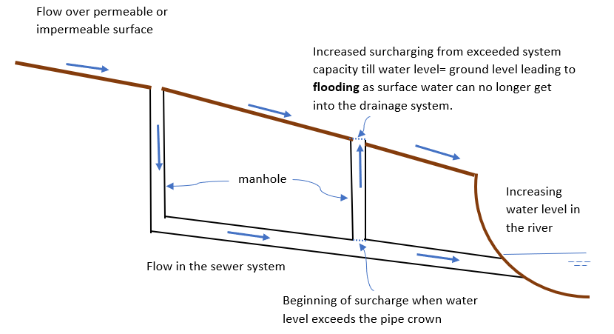

Figure 3:Major and minor flow interactions during an extreme event Adapted from (Schmitt, et al., 2004, Ellis, et al., 2009)

## Development of Decision Support Tools for Floods

Write a bit Here

In most urban areas, simulation models like the EPA’s Storm Water Management Model (SWMM), MIKE-Urban, and SOBEK-Urban, among others, have been used extensively (Riaño-Briceño, et al., 2016) for decision support. These aid in the designing, and analysis of drainage(gray) infrastructure and its control systems (Gironás, et al., 2010). While the use of these modelling systems is invaluable in water management and particularly in flood management, access or comprehension of modelling results is a benefit enjoyed only by those skilled in using these systems. Generally, non-technical citizens would therefore require some training to understand the modelling system(s) or results obtained from these. To bridge this gap, computer programs, called chatbots, that can comprehend users’ requests, and in turn, provide a response understandable to the user have been developed and these are discussed in the proceeding section. The adoption of these chatbot systems would allow citizens to ask any question about flooding in the city and obtain model simulation results in a form that is easily understandable to them.

## Chatbot Technology

As society becomes more and more technologically advanced, Artificial Intelligence (AI) has proven to play a very significant role in everyday life, from smart assistants like Siri, Alexa, or Google assistant to computer games, internet searches engines, smartphone functionalities, chatbots, self-driving cars and even autonomous weaponry. AI allows us to solve complicated issues by imitating how humans learn, understand and use their intellectual abilities to solve problems (Chen, et al., 2008). These advances in artificial intelligence have strongly influenced the development of chatbot technology through advances in natural language processing and machine learning.

While different definitions of Chatbots have been brought forward, the underlying concept of chatbots is that they are computer programs(agents) that can hold conversations with users in a friendly way as one would with a person (Przegalinska, et al., 2019, Setiawan, et al., 2020). They use what is called natural language processing (NLP) which translates human language into computer language and vice versa, responding in a language understandable to the user (Dahiya, 2017).

### The History of Chatbots

The history of chatbots strongly hinges on Alan Turing, who in the early 1950s questioned whether a machine could think. It was only a decade and a half later that the first chatbot was developed. The first chatbots were created to imitate human behavior by recognizing keywords from text input and matching them against some rules to provide a response. ELIZA, was the first to be created in 1966 by Joseph Weizenbaum (Cahn, 2017) at MIT. This was a basic chatbot that used a pattern-matching algorithm to provide answers in a conversation. It however could not grasp the context of the conversation. After ELIZA, PARRY was developed by Kenneth Colby in the 1970s at Stanford to impersonate someone with paranoid schizophrenia. PARRY managed to convince many psychiatrists into believing that it was a real person. In 1995 Richard Wallace started developing A.L.I.C.E (Artificial Linguistic Internet Computer Entity) which was a natural language processing chatbot (Cahn, 2017, Shum, et al., 2018). All of these chatbots performed well, but under constrained situations (Shum, et al., 2018). Further enhancements were therefore done on chatbots such as the incorporation of the ability to fulfill a task, such as providing tourists with flight data (Shum, et al., 2018). Owing to advances in AI, the process of retrieving information improved to a point where responses are obtained from analysis of web search results and the user input is now verbal as is the case with Virtual Personal Assistants (VPA) like Cortana, Siri, Alexa, and Google Assistant (Cahn, 2017). Presently, chatbots are being created to address various issues as alluded to in previous sections.

### Basic Functions in Chatbots

Cahn (2017) quoting Sansonnet et al. (2006) proposes three basic functions that should be fulfilled by every chatbot. Firstly, the chatbot must be able to comprehend what the user is requesting and provide appropriate responses(Cahn, 2017). This is regardless of the type of input that the user uses, which could either be textual, visual or oral depending on the developer’s preference and the purpose of the chatbot. If the chatbot is designed to accept for example both textual and visual input, it should, therefore, under no means fail to support these types of input and provide responses accordingly. For instance, a chatbot designed to serve blind patients would have to incorporate an option for oral communication (Nurdiana and Wijaya, nd) so as to adequately address the users’ needs. Secondly, the chatbot must be integrated with an external database from where it can extract the information needed by the user. These can be static(unchanging) or dynamic(Boné, et al., 2020) getting updated in real-time. Finally, chatbots should “provide the function of presence” or a persona. This is the aspect of chatbots that ensures that they are relatable so that the users trust them (Cahn, 2017 ) and the responses that they provide. The essence of chatbots hinges on the users getting a feeling of communicating with someone who understands their needs.

Their popularity emanates from the fact that they are accessible to everyone as there is no need for the user to have knowledge about computers, they just have to ask questions and answers will be provided. After it analyses and understands (parses) the question the chatbot then provides the appropriate response. The popularity of chatbots has led to their adoption in a variety of fields to accomplish different tasks. Firstly, chatbots have successfully been used in the healthcare sector (Divya, et al., 2018, Kavitha and Murthy, 2019, Nivedhitha, et al., 2021). These chatbots are used to communicate with patients and provide a diagnosis from the symptoms that the patient will have provided the chatbot. The patient can then be prescribed over-the-counter medication to take and prompted to set an appointment to visit a general practitioner where necessary. Secondly, application in agriculture has involved the development of, for example, the AgronomoBot, a chatbot that could access information from a network of sensors in a vineyard and display this to the user (Mostaco, et al., 2018).. Also, chatbots have been used in education to enhance online learning and for creating student enrolment platforms at universities (Reyes, et al., 2019, Deveci Topal, et al., 2021). Finally, other sectors where chatbots are being used extensively include retail, human resources management, banking, manufacturing, insurance logistics and marketing (Quah and Chua, 2019, Cheng and Jiang, 2021), among others. The benefit of chatbots in these sectors is that they enable users to gain instant access to the companys’ products at any time, and be able to query the chatbot if they have any questions.

### Chatbot Applications in Water Resources Management

In aquaculture, chatbot technology has been used, for example, in the development of a chatbot that allowed the user to monitor the water quality in a fish pond through sensors and the Internet of Things (Al Rasyid, et al., 2020)

Write as text not table

As discussed in previous sections, the Chatbots technology has been applied in numerous fields a few of which will be expounded on in this section.

Table 2.6‑1 Flood Awareness in Nigeria (Okon, 2021)

|  |  |  |  |  |  |
| --- | --- | --- | --- | --- | --- |
| **Author, year, Field of application** | **Input to the Chatbot** | **Was it using mobile?** | **What did it solve?** | **What was the justification to do the app?** | **What was the problem being solved?** |
| **Flood awareness** (Okon, 2021) | -NLP was used to convert text that the user input into computer-comprehendible language.  -Several intents were created, together with their respective responses, using a large number of conversational texts in a variety of arrangements (form or pattern).  -Using libraries such as natural language toolkit(nltk), numpy TensorFlow and tflearn, Python code was written to carry out the preprocessing and processing procedures of translating the text into machine language  -180 intents with various patterns and responses were processed, trained and tested using Google Dialogflow. | Yes  A mobile app was developed for integrating the AI Chatbot using the Flutter framework which uses the Dart programming language for the ‘front-end’ and therefore can be used on both Android and iOS. | -Providing flood warning and advisory information  -Integrating flood forecasts into more user-friendly and accessible technical devices, e.g. mobile apps. | -Practical application of the use of AI chatbot technology and NLP techniques in hydro-informatics  -Citizen participation in water management.  - Simulation of human-like conversations between humans and a trained machine capable of responding to queries and doing tasks without the need for additional human participation.  -Timely, well-informed decision-making on an individual basis in the event of an imminent flood.  -Transmission of flood awareness information from flood forecasts in an uncomplicated, interpretable and easily accessible medium | -Difficulty in accessing flood forecast information by the impacted population owing to the numerous steps and procedures required to obtain these results from online sources.  - The afflicted population's inadequate literacy and technological experience, particularly in rural and isolated areas, may hinder their capacity to access the internet in search of existing flood-related information. |

Table 2.6‑2 Ask Diana: A Keyword- based Chatbot system for water- related disaster management (Tsai, et al., 2019)

|  |  |  |  |  |  |
| --- | --- | --- | --- | --- | --- |
| **Author, year, Field of application** | **Input to the Chatbot** | **Was it using mobile?** | **What did it solve?** | **What was the justification to do the app?** | **What was the problem being solved?** |
| **Water-related disaster management**  (Tsai, et al., 2019) | - a database gathering static and dynamic data which used a decision tree for classification  - intent matching was done using a keyword table  - if the user utilized the menus, then matching was directly using the keyword table however when they used text to search the input was analyzed using a Fuzzy-search algorithm and then matched.  - A decision tree was then used to check whether the user’s requests were for data or to search for more information through another menu. It was used to manage and categorize or classify the data.  After this, the system would then enter another phase to process the data and provide the result.  Expert advice and government reports were used to assess data needs.  -Static(a database was created) and dynamic data(APIs used). | Yes  Used LINE platform | -Effective information delivery  -Access to data by clicking menus on the chatbot.  -Different data needs were considered: weather data, past reports on disasters, disaster prevention and drought resistance information.  -Drought and flood prevention  -Visual display of data  -Menu and text input | -Data for disaster-related issues is usually enormous and varied making it difficult for decision-makers to use it during the disaster.  -Decision-support systems are usually complex. | Most decision support systems are designed for those who are proficient in using a computer.  - developing a DSS called Ask Diana which can manage massive data conveying critical information to the decision-makers |

Table 2.6‑3 Chatbot for integration with smart sensors in aquaculture (Al Rasyid, et al., 2020)

|  |  |  |  |  |  |
| --- | --- | --- | --- | --- | --- |
| **Author, year, Field of application** | **Input to the Chatbot** | **Was it using mobile?** | **What did it solve?** | **What was the justification to do the app?** | **What was the problem being solved?** |
| **Aquaculture**  (Al Rasyid, et al., 2020) | Basic techniques of Natural Language Processing (NLP)  integrated with LINE social media app  LINE allows developers to create their own chatbot:  1. Defined classes and features for classification  -naïve Bayes algorithm used to classify data  2. Data collection for text mining-(questions in the fisheries field). Obtained from about 6—articles on fisheries | YES. Client-server developed for web and for Android**(**mobile**)** | -integrate real-time monitoring (sensors) with intelligent aerators (IFTTT- if this then that) on cloud systems.  -Web platform with menus: for all the databases of the system,  -possibility to add nodes,  -allows modification of the IFTTT rules, real-time graphs for each node (e.g. water level, pH, DO)  -allows the user to activate/ deactivate the aerator | -Ease of use of chatbot  -Simulates human interaction.  -No need for manual tests  -Quick and efficient, remote monitoring of the water quality of the system (chemical and physical conditions)  -Monitor values obtained from the sensors  Use of Chatbot to control devices via text commands | -water quality  -Aeration system regulation/control |

Table 2.6‑4 Chatbot for college students placement (Ranavare and Kamath, 2020)

|  |  |  |  |  |  |
| --- | --- | --- | --- | --- | --- |
| **Author, year, Field of application** | **Input to the Chatbot** | **Was it using mobile?** | **What did it solve?** | **What was the justification to do the app?** | **What was the problem being solved?** |
| **Placement activity at College**  (Ranavare and Kamath, 2020) | -Five **intents** developed+ Dialogflow’s welcome intent  -Fallback intent for unrecognized user input-e.g. “Can you say that again”  -Defined new **entities** like departments  -**Fulfillment** allows Dialogflow agent to call the business logic on an intent by intent basis. It is code deployed as a webhook  Allows use of extracted information to trigger actions or generate dynamic responses  -**Context-** used to track the state of the communication, controls the intent and uses previous answers to conduct a conversation  **Integration**- chatbot was integrated into the institute’s website | No. | -A type of virtual assistant to students.  -Easy and quick placements | -It is tedious to search for information on the college website.  -Help desk is not available at all times.  -No need to physically visit the institute | -Placement of college students |

## Research Gaps

From the reviewed literature the following gaps were noted:

* In his research Okon (2021) was working offline with static flood forecasting data which would then need to be updated when new forecasts are received making the whole process rigorous. He recommends that the Chatbot should be connected to an API so that it can run automatic updates. Setiawan, et al. (2020) also recommends the development of a dynamic system. This shows a gap in Chatbot development which this research aims to address.
* In developing Ask Diana, Tsai, et al. (2019) used Fuzzy logic and a keyword mapping table for comprehending the user’s requests which performed poorly when the inputs were long. A more extensive study of the Google Dialogflow platform’s functionalities could, therefore, help improve the Chatbot technology, particularly in natural language processing (Tsai, et al., 2019, Setiawan, et al., 2020, Okon, 2021).
* There is also a need to increase the volume of data input into the Chatbot as this will enhance the training phase and ensure certainty of intent matching leading to a successful response generation Okon (2021).
* There is also a possibility of ensuring that the Chatbot provides maps, graphs or videos as responses to users Okon (2021).
* There is also a need to adequately match the data being revealed as output with the user interface. In the Ask Diana Chatbot, there was a poor display of data obtained from websites on the users’ mobile phones(Tsai, et al., 2019).

|  |
| --- |
| Redo for this chapter  Firstly, the chapter introduced basic concepts on Chatbots. The processes involved from the time a user types their request until they receive a response from the Chatbot were discussed. Secondly, a discussion of flooding in urban areas in light of extreme rainfall events resulting from changes in climate and growth in the urban population was done. Together with this, a description of how flooding occurs resulting from interactions between major and minor flows was included. Following that, a statement problem was defined together with the objectives and research questions to address these problems. Finally, the innovation of the study and the practical value were expounded on. |

1. Technological Tools Used in the Research

Ffjgeroijgfdfpojfdobdf

## Natural Language Processing Algorithms

The development of chatbots primarily centers on advancements in NLP which provides the foundation on which communication between computers and humans hinges. NLP is a branch of AI that involves using several techniques to analyze normal text (Liddy, 2001). Machine learning and deep learning techniques are used in this analysis to improve the understanding of human language by computers so that communication between humans and computers is made possible. Furthermore, NLP incorporates both text and voice analysis. It is categorized into two main branches: Natural Language Understanding (NLU) the process by which computers can understand user input and Natural Language Generation (NLG) the process by which the computer will respond to the user (Ghosh, 2019). NLP is a field of study on its own, which is rapidly changing with advancements in AI. Numerous techniques are used in NLP, and these are described in the following section starting with the different preprocessing techniques.

### Preprocessing Techniques in NLP

Our natural language as humans is the way we communicate with each other, usually via text or speech. So as we evolve, so does our language, and with this transition comes the need to constantly change or upgrade the techniques we use to understand language. The advent of computers enabled various techniques to be performed on our natural language to come up with different ways of understanding it. Firstly, however, the computer needed to understand the text input by a user and to adequately process it and provide a response where necessary. Since the whole concept of chatbot design hinges on NLP, this section is dedicated to discussing the various techniques used in natural language processing.

NLP incorporates both text and voice analysis and is categorized into Natural Language Understanding (NLU), the process by which computers can understand user input and Natural Language Generation(NLG) the process by it which will then respond to the user (Ghosh, 2019). As illustrated in Figure 4, a variety of techniques are used in NLP to understand the users’ input and provide as output, a response that is understandable by the users.



Figure 4: Natural Language Processing Pipeline

#### **Tokenization**

The NLP pipeline comprises of various techniques, the first of which is tokenization. Tokenization involves the splitting of text into smaller units or tokens that can be understood by the computer. Depending on the tokenization algorithm used, text can be split so that the different words in the sentence are used (word-based), or for each word the different letters(characters) of the words are used (character-based) or the words are split into subwords sub-word based as illustrated in Figure 5. When created, these tokens are then mapped with numbers (encoding) so that they can further feed the next stages of the NLP model.

**Word-based Tokenization**

Firstly, tokenization can be word-based, where the text is split on white spaces, punctuation or delimiters (e.g. comma, brackets) depending on the task at hand and the nature of the input data.

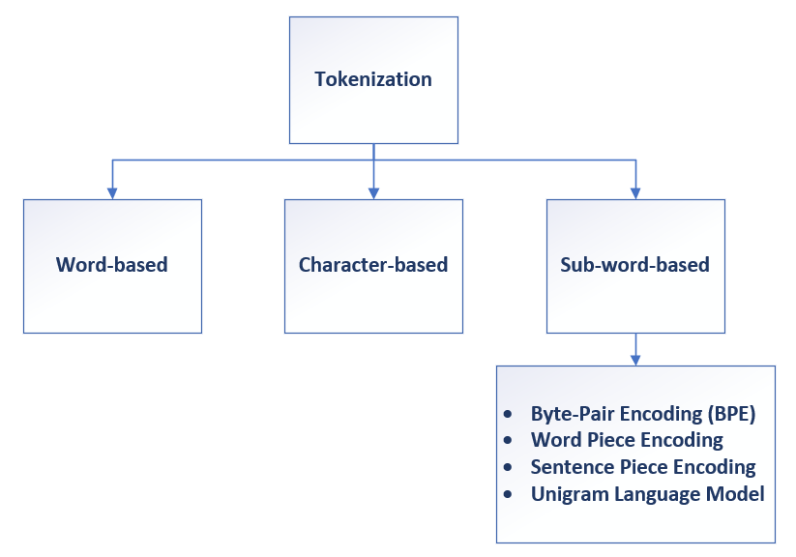

Figure 5: Tokenization

Figure 6 shows an example of how word-based tokenization happens. A pass is made by the computer over the text and firstly, the text is split based on white spaces. After this, it is then split based on punctuation. In this case, care should be taken so that shortened words like “*isn’t*” should not be split as “*isn/t*”, and to prevent this, tokenization exception rules are applied. These then ensure that the word is split accurately as “*is/nt*” so that the meaning of the word is preserved after tokenization. Prefixes, suffixes and infixes (e.g. hyphens) are also used to tokenize text. When all these have been used on the given text whatever forms that remain are considered as a single token. If every single word is extracted individually then the tokens are called unigrams, however, if it is two tokens at a time then they are called bigrams and so forth. The decision on the number of tokens ‘n-grams’ extracted depends on the task to be fulfilled.

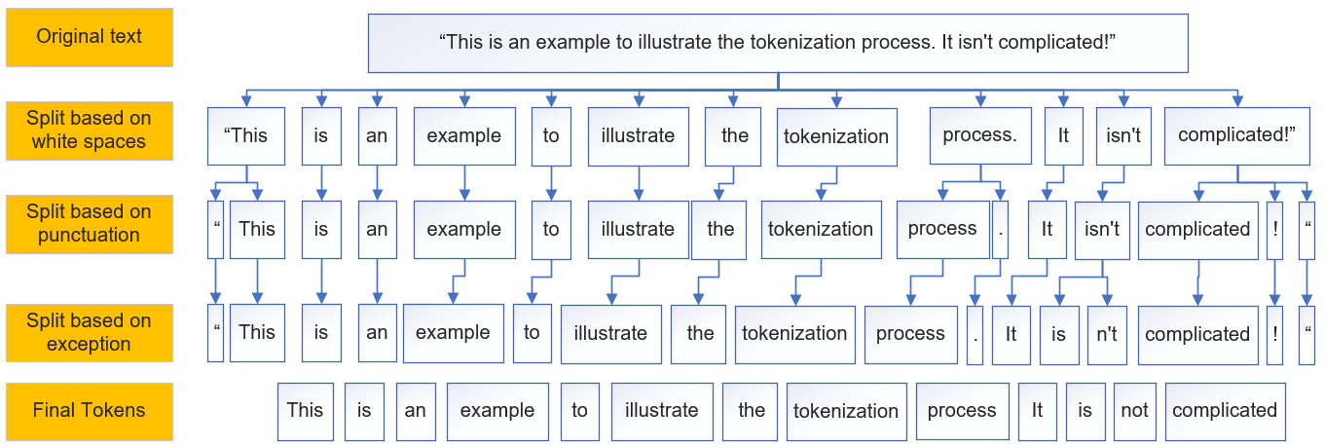

Figure 6: An Illustration of Word-Based Tokenization

This method of tokenizing text has several setbacks including the fact that there is the creation of a large vocabulary to cater for different variants of words e.g. *“let”* and “*lets*” which would then need their own tokens. The second setback comes in handling hyphenated words like “*in-depth”, “ice-cold”* where a set of heuristic rules then have to be developed to enable proper tokenization. A third limitation of the method is that names like ‘*South Africa’* will also be tokenized into *‘South’ ‘Africa’* thereby losing their meaning (Ghosh, 2019). Finally, word-based tokenization would not work on languages that do not use white spaces as separators like Chinese. It is interesting to note that word embeddings like Word2Vec and GloVe which are used in most NLP software fall under word-based tokenization

1. **Character-based Tokenization**

In addition to word-based tokenization, we have character-based tokenization where word characters are considered as tokens as illustrated in Figure 7. Since it is based on characters, encoding of the characters (numbers assigned to characters in computers) can be done using ASCII or Unicode for the embedding of any word. Furthermore, character-based tokenization brings the advantage of increasing the vocabulary that the NLP models can handle since the words are split into letters which can therefore be used to identify any other word with similar letters. It is computationally faster than the other methods. This tokenization technique can accommodate abbreviations, slang and emojis since it considers the character itself. The main setback of character-based tokenization is that the semantics of the word os lost as the tokens (characters) carry no inherent meaning.

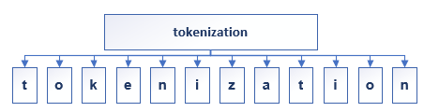

Figure 7: Character-Based Tokenization

1. **Sub-word-based Tokenization**

The main aim of sub-word-based tokenization was to capitalize on the pros of both the word-based and character-based tokenization i.e. retaining the meaning of the tokens and reducing the vocabulary size. The splitting of words is done using prefixes and suffixes and the resulting sub-words can be put together to create other words. Figure 8 illustrates sub-word tokenization showing how the different sub-words are used in the creation of other words. In the figure, the word informatics is split into ‘*in-form*’ adapted from Latin in-forma (informare) meaning to form/shape/ describe to someone and ‘*matics’* from the Greek meaning to act on its own or thought. The subwords can then be used to form other words as prefixes e.g. ‘inform-ality’, ‘inform-ation’ or as suffixes ‘auto-matic’ and ‘schematic’.

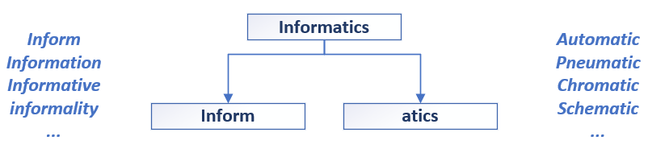

Figure 8: Subword Tokenization

Add more from presentation

#### **Parts of Speech Tagging**

This refers to when words in a sentence are tagged into or assigned their parts in speech, ie whether it is a noun, verb or adjective and so forth in relation to other adjacent words. Tagging is therefore dependent on the context in which the word is used. This technique can assist in distinguishing whether the word is being used for example as a verb or a noun. An example is the word ‘*help*’ which can be used as a verb (‘*May I help you carry that*?’) or as a noun( ‘*Their help was greatly appreciated*.’).

Before the advent of computers, Parts of speech tagging was done manually and this was a cumbersome process. While computers have lessened the process, automatic PoS tagging is made difficult by the ambiguity in most English words. Manual tags are therefore sometimes used as a checking mechanism to the automatic process. PoS tagging is done in different ways, such as following a set of context rules to determine the appropriate tag for the given word (rule-based tagging) or using frequencies to assign the most likely tag(statistical tagging) or a combination of both (transformation-based tagging).

#### **Stop Words Removal**

In most text corpus, there are a lot of frequently occurring words that do not add much meaning to the sentence and these are called Stop words. These are prepositions and pronouns such as ‘*a*’, ‘*the*’, ‘*am*’ ‘*of*’, ‘*at*’, ‘*to*’ and so forth which are eliminated because their absence does not affect the sense or meaning of the sentence. An example of stop words removal is shown in the diagram below.



The process of removing stop words involves performing a look-up for a set of stop words in a list. While there are numerous stop words lists, a comprehensive list covering all stopwords does not exist and thus one can adopt any list and add any words they may deem necessary. It is worth noting that the removal of some of these words may completely alter the meaning of the sentence. An example is the word ‘*not*’ which negates the sentence and its removal, therefore, transforms the sentence into having a positive meaning.

#### **Normalizing Text**

Text normalization is a process that involves converting text into standard form e.g. ‘*doing*’ and ‘*does*’ are normalized back to ‘*do*’. Also, words with the same meaning like ‘*SA*’ and ‘*South Africa*’ are normalized into one form. Lemmatization, stemming and correcting spellings are varied ways of normalizing text (Ghosh, 2019). Lemmatization and stemming are both useful algorithms in search engines and other platform where relationships and similarities in words are of importance.

##### **Stemming**

This process involves trimming words so that only their stem remains and is done through the removal of affixes that is prefixes and suffixes. The resulting stem does not necessarily have to be a whole word. Some stemming algorithms use simply rules like removal of suffices like ‘*ed*’, ‘*ing*’, ‘*ly*’ when the algorithm comes across words with such suffices. An example of suffix stemming is ‘*coming*’ becomes ‘*come*’ while ‘*firing’* becomes ‘*fire*’. This can, however, be a challenge since some suffices are used to create different words in the English language for example the ‘*ist*’ in ‘hydrologist’, and ‘*scientist*’ create totally new words which if stemmed lose their intended meaning.

In addition, since stemming does not consider the meaning of the stem produced, there are errors encountered where words with different roots are stemmed to the same stem. This error is called overstemming. On the other hand, understemming is another error where words with the same root are stemmed to different stems e.g. ‘*alumnus*’ and ‘*alumnae*’ being stemmed into different stems while they both have the same root. Regardless of the errors that are sometimes incurred, stemming has the advantage of being fast and straightforward. Lemmatization algorithms have been noted to produce better results since it considers the dictionary meaning of the words. This algorithm is discussed in the following section.

##### **Lemmatization**

As stated in the section under stemming, the main difference between stemming and lemmatization is that the latter considers the dictionary form of the words while stemming does not. Therefore, lemmatization gives the dictionary form of a set of words which is called the lemma. Figure 9 illustrates the difference between the two techniques, and from the figure, it can be noted that Lemmatization takes cognisance of the meaning of the word regardless of its tense while stemming only removes the inflection of the word i.e. ‘ing’ or ‘en’ in this case. Another example by Ghosh (2019) shows how the lemma of the word ‘*products*’ is ‘*product*’ while ‘production’ will remain ‘*production*’. If however, we use stemming, the stem of both would be ‘product’.

Since dictionary forms are required, lemmatizers are more difficult to build as they require more knowledge about the language structure. In this case, it is therefore also important to assign the right parts of speech for the given word in order to obtain its correct meaning. As a result, lemmatization takes a longer time compared to stemming. In terms of its application, lemmatization can be used in chatbot development where we require an understanding of the users’ questions to provide the appropriate response.

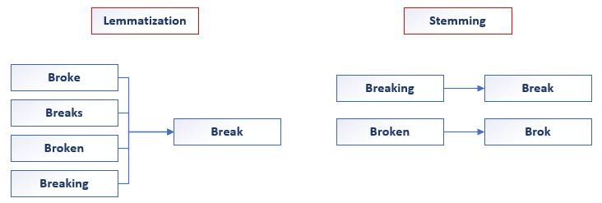

Figure 9: Lemmatization vs Stemming

**Word Sense Disambiguation and Sentence Boundary Detection**

Other techniques used in NLP preprocessing, usually together with other methods discussed in the preceding sections, include Word sense disambiguation and Sentence boundary detection. Word sense disambiguation refers to when words are matched to their intended meaning for example ‘bank’ could mean a river bank or a savings bank. The disambiguation process, therefore, ascribes the true meaning of each word as it is used in the sentence, while Sentence boundary detection is for determining the end of a sentence and the beginning of another. This process is however complicated by words that are abbreviated for instance ‘*Mr.’, ‘Mrs’, ‘Dr*.’.

### Vectorisation in NLP

### Word Embeddings in NLP

## Dialogflow

Jsoefijsld

### Intents

### Context

## Webhooks

The same way humans communicate with each other, computer applications also have their own way of sending messages to each other. The way they do this is by ‘pushing’ or ‘pulling’ messages from other computer applications. There are different ways of transferring this information between computers e.g. polling or webhooks. In polling one program has to continuously check the state of the other programs to see if they have anything to communicate. It is as if the program is continuously asking, “Do you have something for me?”. On the other hand, webhooks are ‘hooks’ used by computer applications to automatically send information to other applications whenever something happens. Webhooks must therefore strictly communicate through a web protocol. This process occurs automatically and whenever there is an update on one application, then the other is automatically updated. The message or payload which they carry is sent to a unique URL and the simplest way to send this is through an ‘HTTP GET or POST request’. Since each user gets a unique random URL to send information to, webhooks are secure, but a key or signature can be used to further secure them.

### Flask

Flask is a web framework for the backend for developing web applications using Python. It was developed by a group of people called Pocco led by Armin Ronacher. It has a development server and debugger built into it. It allows for integration with other APIs and services. It is based on Werzeug WSGI (Web Server Gateway Interface.) toolkit and the Jinja2 template engine. WSGI is a calling convention used by web servers to forward requests to web applications in Python. Werzeug, on the other hand, implements requests and responses. In Flask, the route() function is used to tell the application which URL is supposed to call the linked function. The run() method is for running the application on a local server.

## EPA SWMM

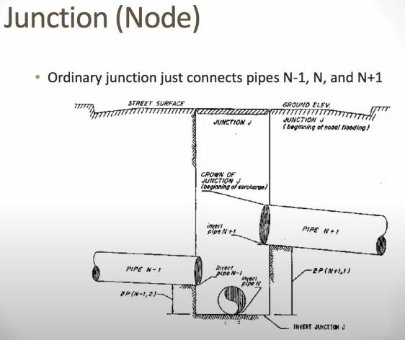

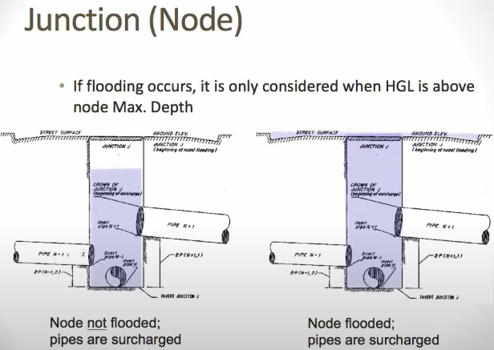

In flooding the node is converted into a storage element. If we use the junction node one additional attribute we supply are a ponded area and a ponded depth (depth of the water above the ground surface). Treats the node as a vertical wall storage tank. Helps to show which nodes flood and which ones don’t.

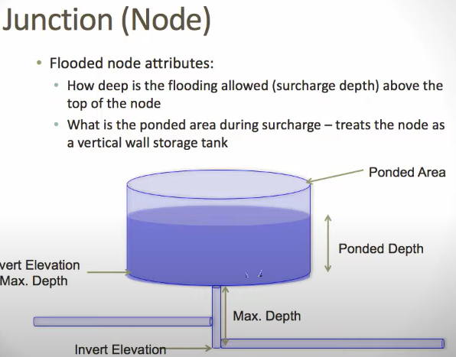

**SWMM negative flow**

Extran has a convention that the upstream node invert of a conduit is equal to or above the downstream node invert of a conduit. It does this for the "normal" flow equation in Extran since the "normal" flow equation uses the upstream area and hydraulic radius to calculate the flow. If you have an adverse sloped conduit, the program will reverse the upstream and downstream nodes so that the upstream is above the downstream node. The flow and velocity going from the new upstream to the new downstream has a negative sign. Flow traveling from the old upstream to the old downstream will have a positive flow even though it is a flow reversal.

openswmm.org

This should only happen for adverse sloped conduits - you might have a case where the slope has a small negative slope.

Vestibulum ante ipsum primis in faucibus orci luctus et ultrices posuere cubilia Curae; Fusce id purus. Ut varius tincidunt libero. Phasellus dolor. Dolor sit amet, consectetuer adipiscing elit, sed diam nonummy nibh euismod tincidunt ut laoreet dolore magna aliquam erat volutpat. Ut wisi enim ad minim veniam, quis nostrud exerci tation ullamcorper suscipit lobortis nisl ut aliquip ex ea commodo consequat. Duis autem vel eum iriure dolor in hendrerit in vulputate velit esse molestie consequat, vel illum dolore eu feugiat nulla facilisis at vero eros et accumsan et iusto odio dignissim qui blandit praesent luptatum zzril delenit augue duis dolore te feugait nulla facilisi.

Ipsum lorem dolor sit amet, consectetuer adipiscing elit, sed diam nonummy nibh euismod tincidunt ut laoreet dolore magna aliquam erat volutpat!Maecenas vestibulum mollis:

Equation 2.1—1 Ipsum lorem dolor sit amet

$$f\left(x\right)=a_{0}+\sum_{n=1}^{∞}{\left(a_{n}\cos{\frac{nπx}{L}}+b_{n}\sin{\frac{nπx}{L}}\right)}$$

Ipsum lorem dolor sit amet, consectetuer adipiscing elit, sed diam nonummy nibh euismod tincidunt ut laoreet dolore magna aliquam erat volutpat!

|  |  |
| --- | --- |
|  |  |
|  |  |

Figure 10 Inse dolore magna aliquam

Table 1 Dolor sit amet, consectetuer adipiscing elit

Blandit praesent luptatum Ipsum lorem dolor sit amet

|  |
| --- |
| End each chapter with a short summary and/or conclusion   * What do we know after reading this chapter that we didn't know before? |

1. Study Area

Ffjgeroijgfdfpojfdobdf

## General Description

The SWMM model used in the study is for Do Lo an area lying to the south of Yen Nghia ward in the Ha Dong District of Hanoi, the capital city of Vietnam. The general climate in Vietnam is tropical in the southern parts of the country and monsoonal in the North (Groen and Jacobs, 2012). Hanoi receives rainfall every month with the driest months (December and January) having on average around 19mm. Figure 13 shows the average annual rainfall received in the area between 1975-2018 and this is generally high at above 800mm with most years being above 1000 mm. In 1994 and 2008, the area received rainfall in excess of 2000mm. Due to the high amounts of rainfall received, flooding is thus prevalent in the area.

In terms of natural disasters, the country experiences varied natural disasters including sea-level rise, tropical storms, floods, mudslides, droughts and earthquakes as highlighted by Groen and Jacobs (2012). Flooding usually occurs several times in a given year, mostly on the coasts and closer to rivers. To add to this, most of the population resides in these high-risk areas and this compounds the impacts of the floods leads to deaths and annual economic losses. According to Nguyen, et al. (2021), southern and central Vietnam usually experiences river flooding, while the northern mountainous areas are affected by cyclones and typhoons leading to flash floods. Population growth and the resulting development have led to the construction of buildings in flood-prone areas which exacerbates the flooding situation in the area by introducing more impervious surfaces.

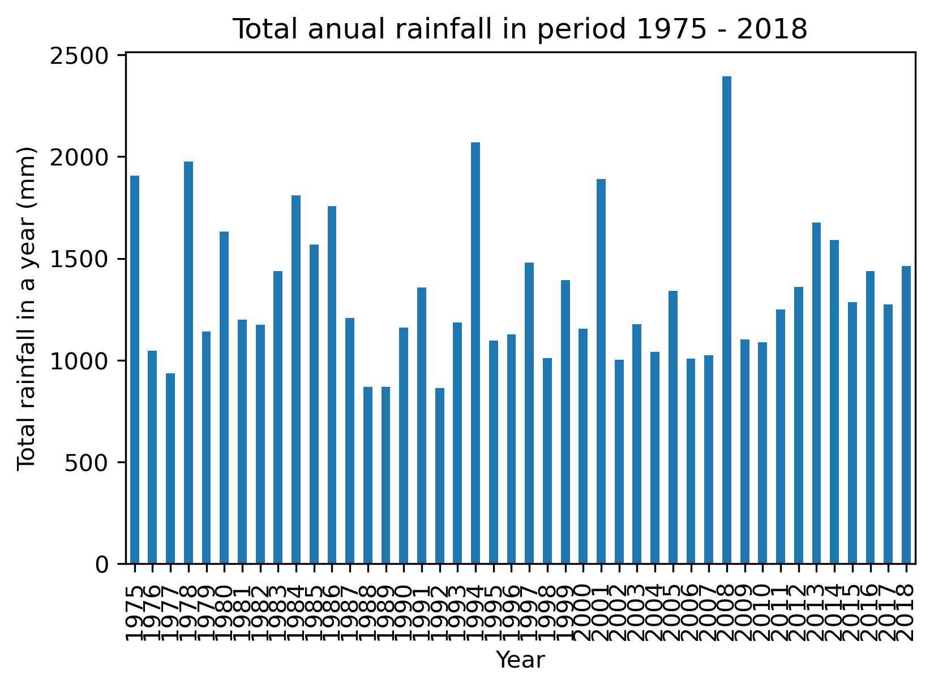

Figure 11: Annual rainfall 1975-2018

Do lo was initially an old village, but as areas around it developed it also grew into being part of Yen Nghia ward when Ha Dong was awarded city status in 2006 (Vietnamese Government, 2006). It is in the Ha Tay province. The location of the study site is shown in Figure 13. Do Lo, Yen Nghia is about 61.5 ha in area and is located next to the Yen Nghia dyke. It is this dyke that protects the area from any flooding from the Day River which lies to the west of the ward. The Co Ban channel, located to the South and the East of Do Lo, is the main output of the drainage system in the study area. The Co Ban channel is connected to the La Khe channel, which later connects to the Day River through Yen Nghia Pumping Station and also through a gate in the West. Connection to the Nhue River is through the Van Phuc gate. Belonging to the Red River delta, Do Lo, Yen Nghia is part of Hanoi the capital city and has the same geographic, climatic and meteorological characteristics as Hanoi: a flat geographical landscape with an average elevation of 5.00 m amsl. The average temperature is +23oC and the lowest annual temperature is +5oC and the highest annual temperature is +38oC. With over 10373 residents (census survey data 2019 – people’s committees of Ha Dong District), Do Lo, Yen Nghia is quite a dense area with a population density of 16862 persons per square kilometer (Do, 2021). Figure 14 displays the land use in the area, showing a fair proportion of green spaces and some water-covered spaces. The larger portion of the area is built up. Figure 16 shows the annual rainfall received in the area during the period 1975-2018.

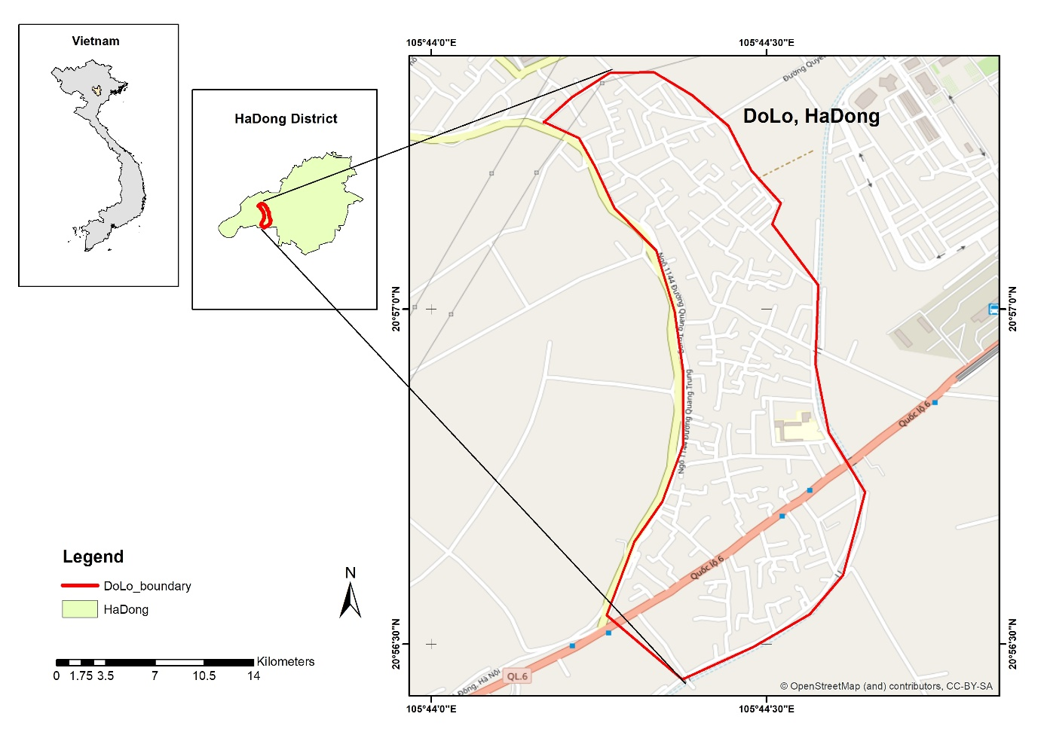

Figure 12:Do Lo, Hanoi, Vietnam

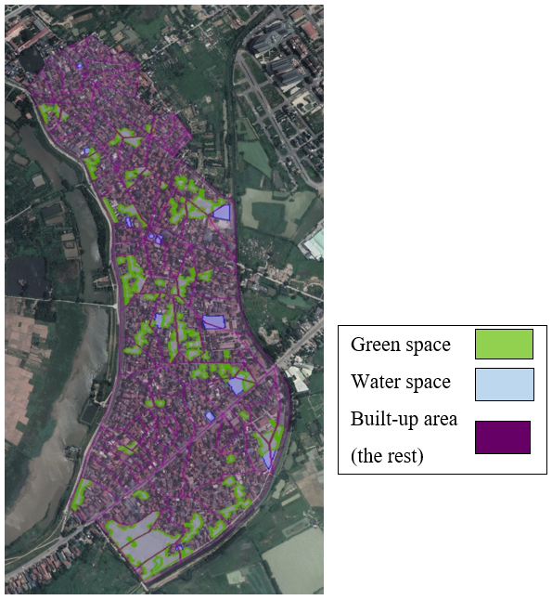

Figure 13:Landcover in Do Lo, Yen Nghia, Ha Dong Source:(Do, 2021)

## Flooding Trends and Awareness

Flooding in the area occurs annually with the rain falling at intensities of over 30mm. According to Nguyen, et al. (2021) 50-80% of the annual water volumes are received during the flooding season (October to December). He also discusses the occurrence of floods in the period between 2012-2015 in many areas including Hanoi (Nguyen, et al., 2021). In a report for 2021, the IFRC reported the death of 291 people (108 from flooding) with 66 missing and 876 injured from natural disasters. Flood control in the area is mainly in the form of dykes(Nguyen, et al., 2021). In addition, the government instituted flood protection measures including the National Strategy on Disaster Prevention, Response and Mitigation policy document to address disaster risk management (Groen and Jacobs, 2012). In addition, to reduce vulnerability to the impacts of climate change, the National Target Programme on Climate Change Adaptation was introduced in 2009. Emergency response teams were established and early warning systems are in place. However, at local levels, there is little preparedness and low stakeholder participation in planning for risk reduction(Nguyen, et al., 2021).

## The Urban Drainage Network in Ha Dong

The drainage system of the area is shown in Figure 17. It has 3 outlets (shown by the yellow stars on the map) which discharge to Co Ban Channel. The drainage system is almost divided into 2 separate sub-systems, one to the north and one to the south. There are however still some pipes in the middle, therefore, the system is considered as a whole. Write more here number of links.

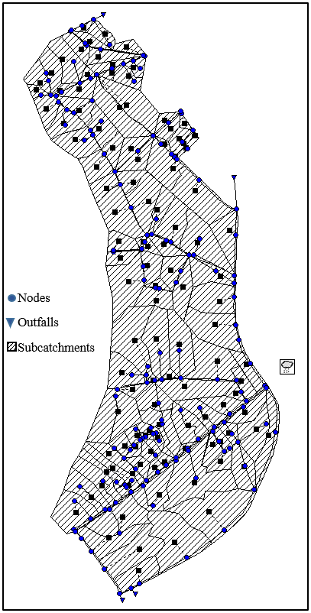

Figure 14: Drainage system in Do Lo, Yen Nghia, Ha Dong

Source: Hanoi Sewage and Drainage system Company (HSDC)

|  |
| --- |
| End each chapter with a short summary and/or conclusion   * What do we know after reading this chapter that we didn't know before? |

vkdjbfv

1. Methodology

Intro

Put a flow chart of the whole methodology here

## Comprehending NLP Algorithms

### Tokenization

Lemmatization is of paramount importance in chatbot development where matching of similar text is fundamental to the subsequent matching of intents and responses.

The Natural Language Toolkit (NLTK) library can be used in Python to perform all of these techniques

### Byte Pair Encoding

### Stemming

### Lemmatization

## Chatbot Development Using Dialogflow

Put a flow chart here

### Dialogflow Appointment Scheduler

To understand how Dialogflow works an appointment scheduler was developed in Dialogflow to set an appointment on the Google calendar API. This section describes the steps taken in building the Appointment scheduler in the Dialogflow console shown in Fig (DELETE???)

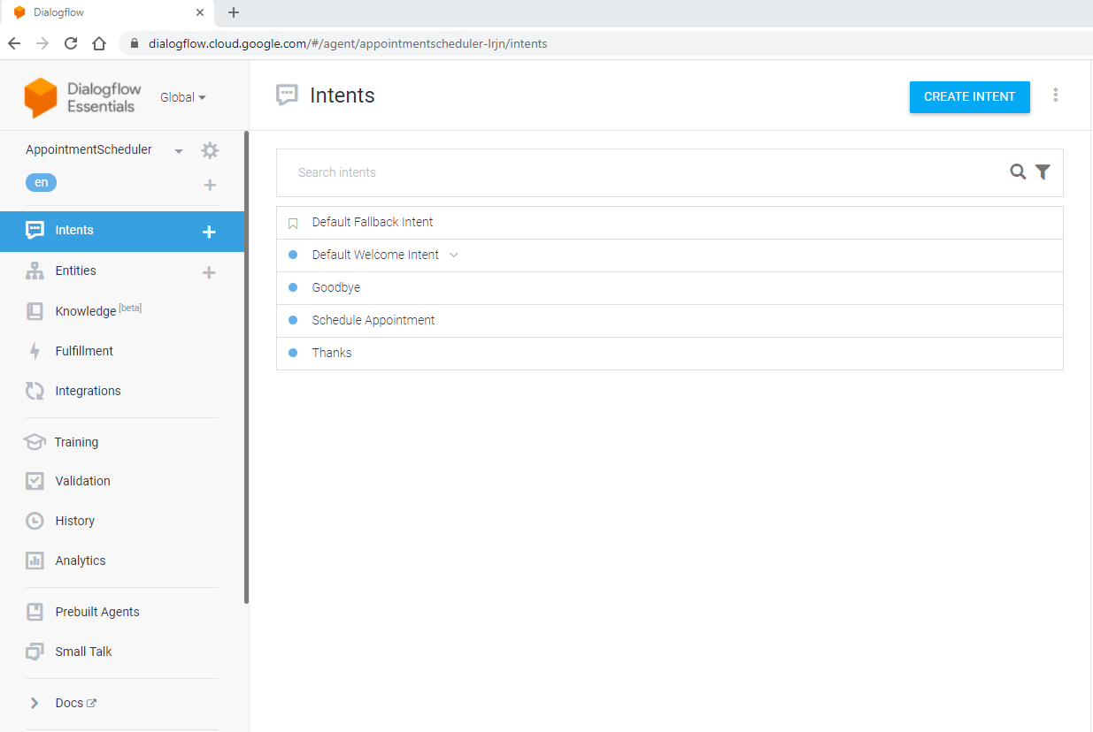

Figure 15: Dialogflow Console

The first step in creating the chatbot involved developing a set of intents with corresponding responses for each intent. Dialogflow already has two defaults intents, the Welcome intent and the Fallback intent. The welcome intent has, as training phrases, a set of expressions that different users use in greeting, such as “*hi there*”, “*greetings*” and so forth. To increase the relatability of the chatbot, non-formal phrases like “*what’s up*”, “*hey*”, were added to the welcome intent. The default responses to this intent were also modified to introduce the chatbot to the user as shown in Figure 18, outlining the functionalities of the chatbot i.e what it can do for the user.

|  |  |
| --- | --- |
| Sample responses for the Welcome intent |  |
|  |  |
| Sample response for the Fallback intent |  |
|  |  |

Figure 16: Sample responses for the Welcome and Fallback Intents

The default fallback intent is called every time the chatbot fails to understand the user’s request. An example of such a response is shown in Figure 18. Through this intent, the chatbot prompts the user to rephrase their question so that it tries to match it with the appropriate intent.

Since the purpose of the chatbot was to set an appointment, the Schedule Appointment intent was created. Figure 19 shows some of the expressions input into this intent as training phrases and as can be seen from the figure, this intent used system entities like ‘date’(*@sys.date*) and time (*@sys.time*). This is key information that it needs to capture from the chatbot. For these system entities, the user would be prompted to input the date and time they would like to have the appointment.

In addition to the system entities, another custom entity named ‘Appointment type’ was created to prompt the user to choose which type of appointment they wanted to set, between thesis update, driving license renewal, passport renewal, and dental service. So whenever the terms ‘*driving license*’ or ‘*thesis/ thesis update*’ etc are mentioned, the chatbot automatically matches it with the ‘Appointment type’ intent ’For the response, through fulfillment, Dialogflow would then, extract the entered date and time and set the appointment in the Google Calendar Platform for the appointment type selected by the user.

|  |
| --- |
| 1. Training Phrases |
|  |
| 1. Actions and Parameters |
|  |
| 1. Response |
|  |

Figure 17: Schedule Appointment Intent Set-up

Through fulfillment, the Appointment scheduler chatbot could then be integrated or connected with the Google Calendar API. To achieve this, the Google Dialogflow Inline Editor was used where a JavaScript(JS) file was added. These were obtained from an open-source code on Github (Kumar, 2021) and edited to add the service account, calendar ID., time zone and time zone offset. The following step involved enabling the Google Calendar API on the Google Cloud Platform (GCP). After this, a service account was created under the credentials tab of the GCP. The service account is used to run the Google Calendar API requests. Once the service account has been created, a service account key is generated which is in JSON (JavaScript Object Notation), a format used in sending data between computers. From the generated key, the client email is copied to the Calendar under ‘*Share with specific people*’, with permission to make changes to calendar events. Likewise, the Calendar ID is obtained from the Google Calendar platform and used in the Inline editor of the Dialogflow platform. In the same Inline editor, the service account information is added. Once all this is done, the integration process is completed and the chatbot is ready to be used. Screenshots of the resulting chatbot are shown in Chapter 6

### Dialogflow: SWMMBot

Since the research’s aim was to extract information from an EPA SWMM model, the chatbot was named SWMMBot. The steps taken in developing this chatbot will be discussed in this section borrowing from the lessons learnt in developing the Appointment Scheduler chatbot described in the preceding section. The first step involved defining the intents of the users in line with flooding in the Do Lo area of Ha Dong.

#### **Scenario Definition**

The main purpose for developing the chatbot is to help users access flooding information for the area they are located in based on results abstracted from the EPA SWMM model. The idea is if a user is in one part of the town, they would want to find out first which areas are flooded so that they can avoid such areas where possible.

#### **Intents Development**

So the first intent was on the location of the flooded area. This was done by mapping this with flooded nodes in the EPA SWMM model at a given time. Secondly, the user may want to know the duration of the flooding in the different areas and thus a flood duration intent was developed. This would help users access the possible impact of flooding on e.g. vehicles and if these could be moved to non-flooded locations. The third intent focused on the maximum ponded depth. This would in general assist the users in deciding whether to move or stay put if the floodwaters are too high. It could also help in deciding which flood barriers would be appropriate for the expected water depth. The fourth intent was developed for the time of maximum occurrence of the flood. The fifth intent was for the maximum flooding rate for the area. This would be important for those who would like to know the maximum rate at which an area is getting flooded.

Put fig here

#### **Entity Development**

With screen shotsy

#### **Small Talk Set-up**

With screen shots

#### **Small Talk Set-up**

EPA SWMM extraction algorithms

With screen shots

## Chatbot Integration Using Webhooks

As discussed in Section 3.3, the way webhooks works is that if something happens i.e. an event is triggered in the ‘source’ application, it will be serialized and sent to the webhook URL of the ‘receiving’ (action) application i.e. the one that acts on the information sent. The ‘receiving’ application will then send a confirmation (callback) response message to let the ‘source’ application know that the information it sent was successfully received or not. This would be done using an HTTP status code like 302 for successfully received and 404 if not successful. Webhooks were therefore used to integrate the functions developed to extract data from the EPA SWMM model with the Chatbot agent created in Dialogflow. Fro this the Flask web framework was used as detailed in the proceeding section.

In Flask, the route() function is used to tell the application which URL is supposed to call the linked function. The run() method is for running the application on a local server.

Describe the processes in Flask

## Web Design

To enable communication between the user and the chatbot a Graphical User interface (GUI) has to be developed. Different kinds of interfaces can be used including websites, mobile phones, xxxx

Some of the languages used in web design include the Hypertext Mark-up Language (HTML) and Cascading Style Sheets (CSS), JavaScript, PHP and Python. HTML and CSS are usually used on the client-side and Python and was used on the server-side

### HTML

In creating websites different programming languages are used including HTML, CSS, JavaScript, PHP and Python.

#### **HTML**

HTML is a language that

**Images**

Background images can be added to the webpage by specifying the url for the image under the background-image property of HTML. The image width and height are specified in pixels or percentages. If the background-size property is set to ‘contain’, the image will fit the area of the content keeping the aspect ratio while setting it to ‘cover’ may lead to having some part of the background image being clipped off. Other images are added using the <img> tag specifying the source of the image together with its height and width properties.

### Cascading Style Sheet(CSS)

#### **Cascading Style Sheet (CSS)**

**Color**

Modern browsers are said to support 140 named colors. These can be defined in various ways in CSS, including predefined color names, hexadecimal code colors and RGB code colors and options that specify values for the HSL(hue, saturation and lightness). Firstly, colors can be defined using direct color names like cyan, gray, white etc. The second method involves the use of hexadecimal colors which are specified using hexadecimal numbers between 00 and FF comprising of RRGGBB (red, green and blue). Red is #ff0000 and blue is #0000ff. To add transparency two additional numbers between 00 and FF are added in front. Another way of defining colors involves using the rgb() function where one inputs values between 0 and 255 (or percentages) to define the intensity of either the red, green or blue color. An alpha parameter can also be added in front of the rgb function to describe the opacity of the entity. An alpha value of 0 signifies a fully transparent color and 1 is fully opaque. Finally, a hue, saturation and lightness (HSL) function can also be used in defining colors. The degree on a color wheel where 0 is red, 120 green and 240 blue determines the hue. The saturation is a percentage between 0, a shade of gray and 100%, which is full color. For lightness 0% os black and 100% is white. The alpha property can also be added to specify the opacity of the color.

## Webpage design

To enable the user to interface with the chatbot and thereby allow for communication, a webpage was designed using the Hypertext Mark-up Language (HTML) and Cascading Style Sheets (CSS). HTML and CSS were used on the client-side and Python was used on the server-side. To structure the webpage HTML tags were used to describe how the elements were to appear and a brief description of these ensues.

### Hyper-Text Mark-up Language (HTML)

#### The Head

In HTML, the head

#### The Body

The <img> tag was used to add images to the webpage. Within this tag, the source of the image has to be stated and any styles such as the width and height of the image. These attributes have to be stated so that upon loading the page, there is a reservation of the space that will be required for the image. Failure to do this may lead to a change in the page layout during loading. The values assigned to these attributes are usually in pixels or percentages.

### Cascading Style Sheet (CSS)

#### The Body

**Images**

In formating the images, they were set to be responsive by setting the height to ‘auto’ and the width to a max-width of 100% so that they wouldn’t be scaled up beyond their original size.

**Lists**

The ‘::before’ selector is usually used to insert something before some content, but in this case, it was used in changing the color of the bullet points to red. The content property was used with this selector to specify the content to insert.

**Colors**

For the headings and the navigation bar predefined background colors were used, i.e. colors written in normal text like ‘dark-blue’, ‘gray’ and ‘powder-blue’. The same applied to font color for different text on the webpage, where ‘black’, ‘white’ and ‘firebrick’ were used. For easier access to color names, the [www.htmlcolorcodes.com/color-names](http://www.htmlcolorcodes.com/color-names) site was used.

#### The Footer

Xefhfw

For formatting the fonts, colors, headings, etc. CSS was used.

JavaScript was used for interacting and accessing HTML objects.

Finally, Python was used for executing commands for reading, transforming and writing data, performing calculations, running executable files and finally sending the results to the client (Alfonso, 2021).

## EPA SWMM Model Setup

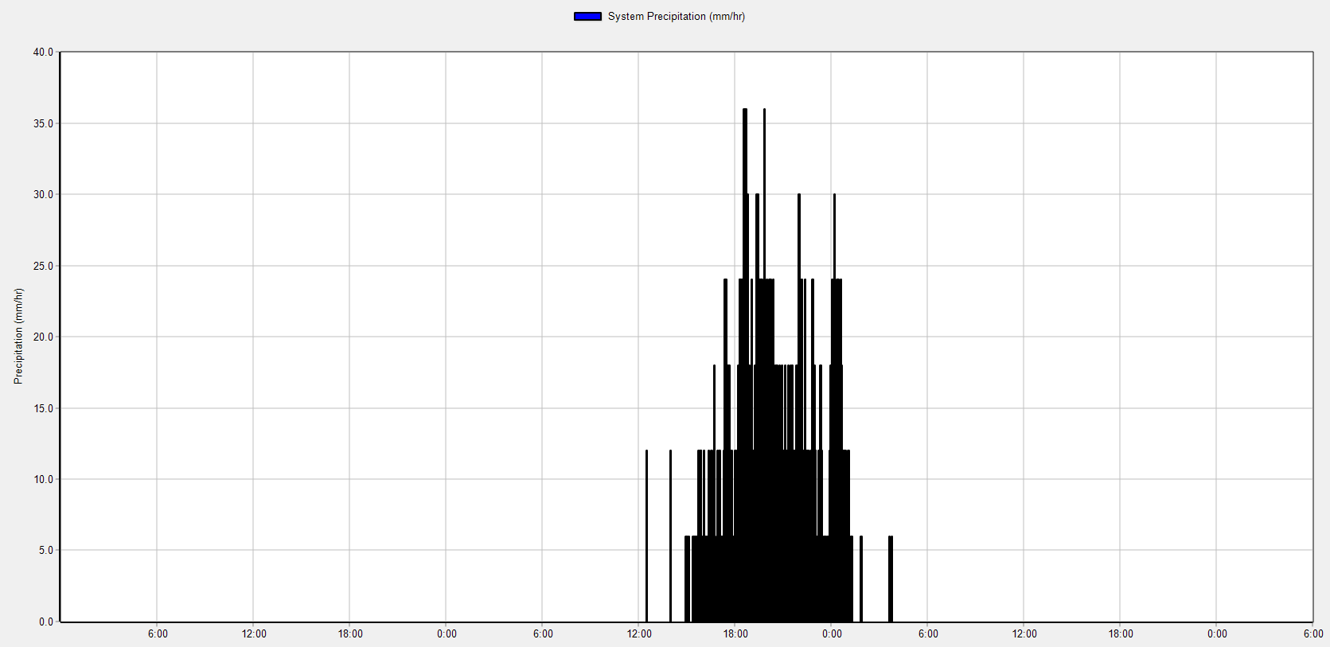

System Precipitation (real)

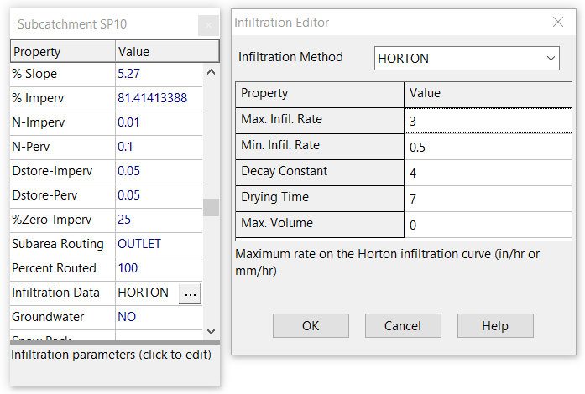

Vestibulum ante ipsum primis in faucibus orci luctus et ultrices posuere cubilia Curae; Fusce

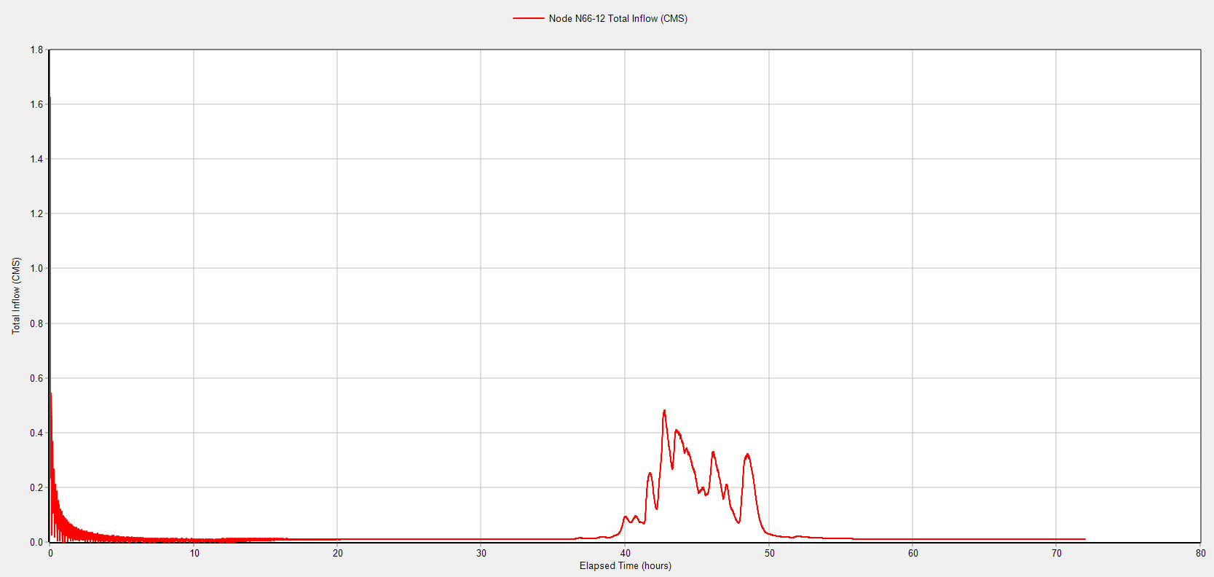

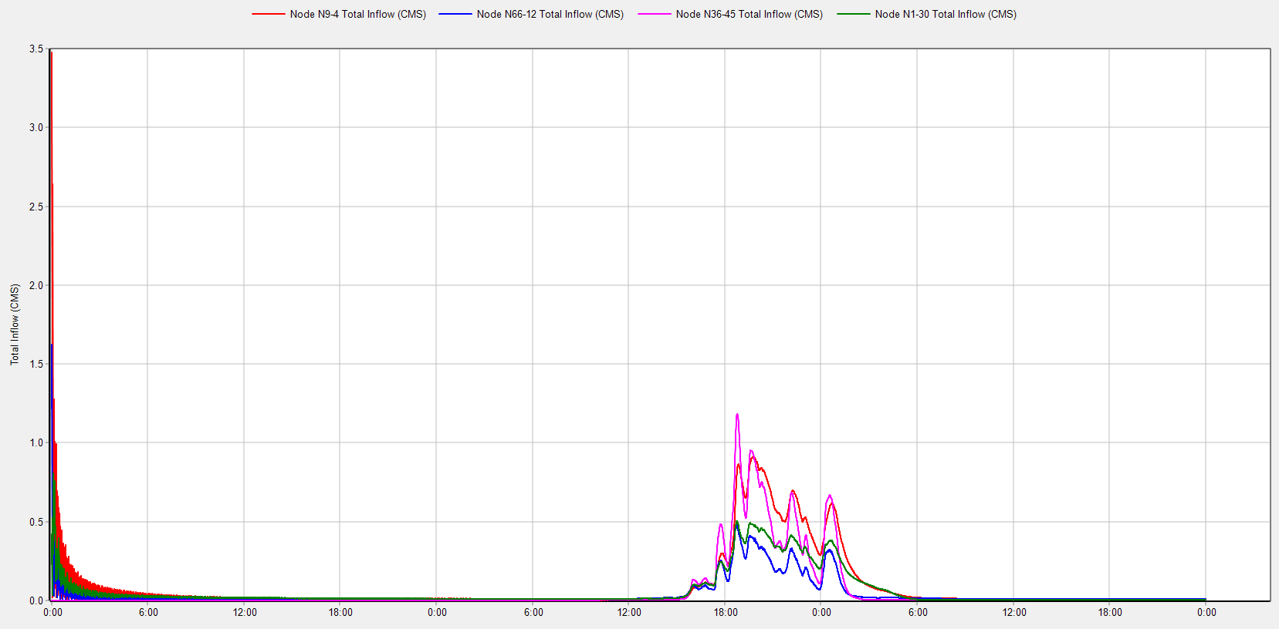

Total inflow for the different outfall nodes (real)

|  |  |
| --- | --- |
|  |  |

Status Report for (10year scenario) put for real situation.

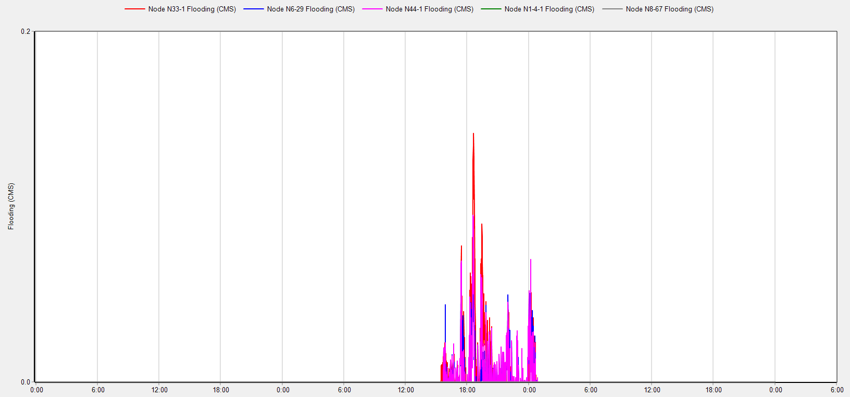

flooding

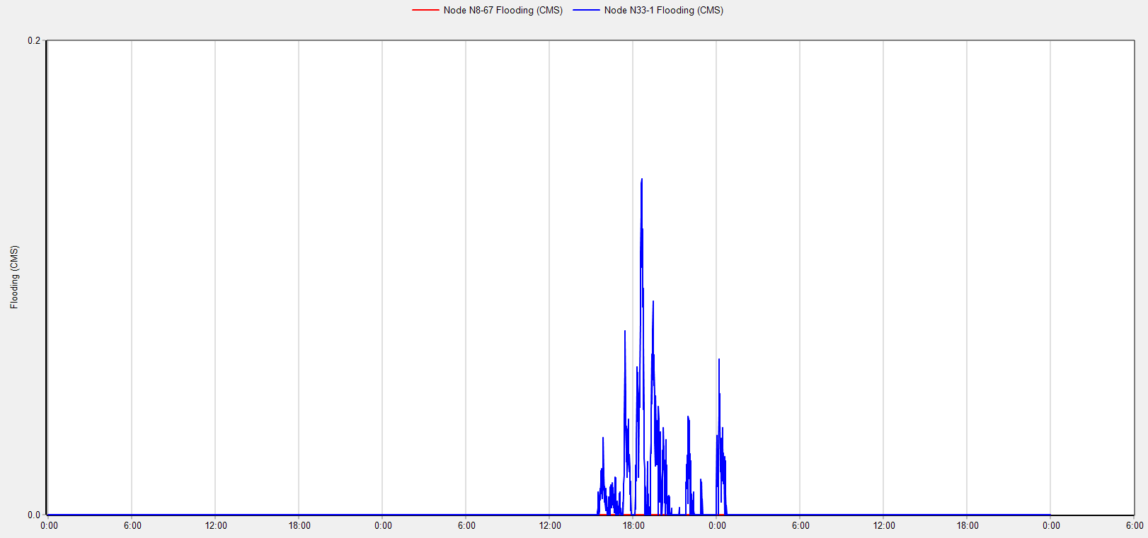

One flooded and one unflooded node

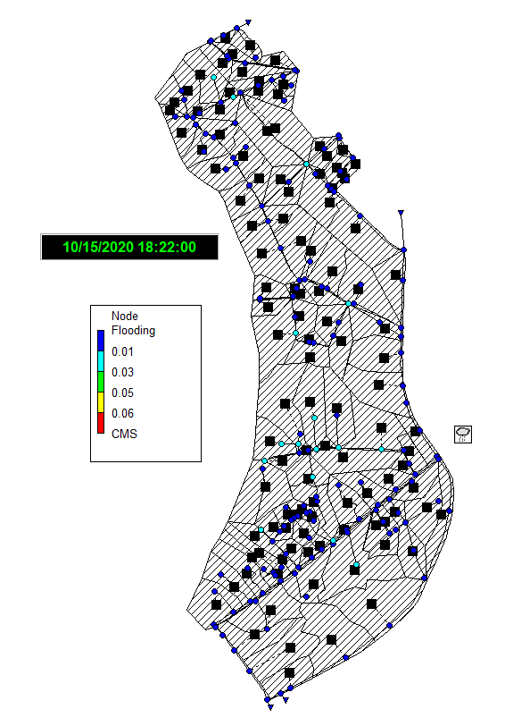

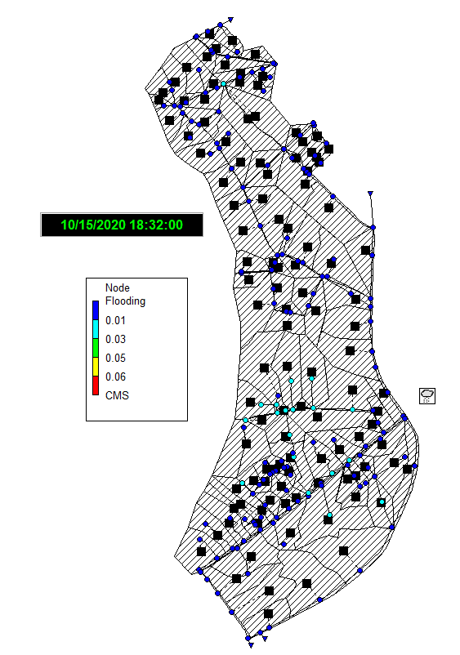

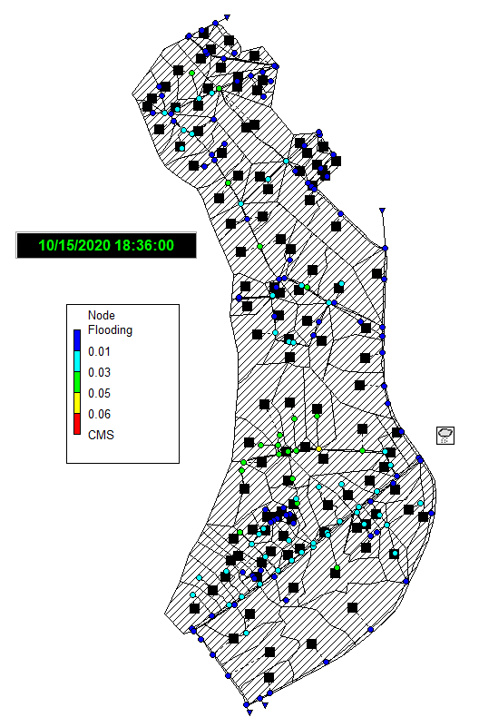

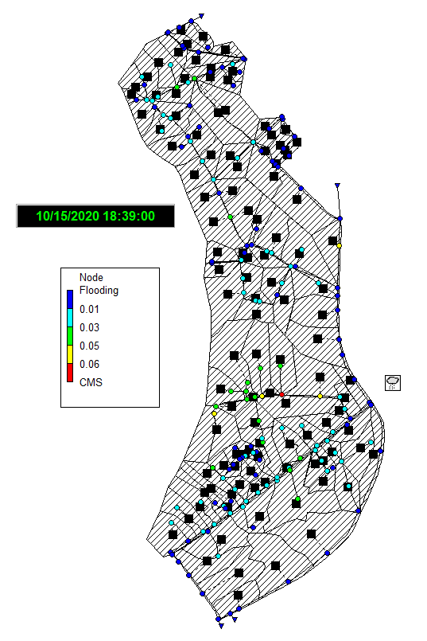

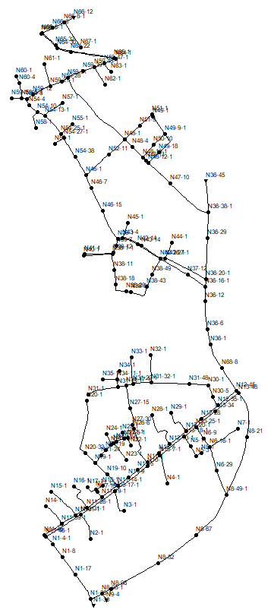

Node IDs

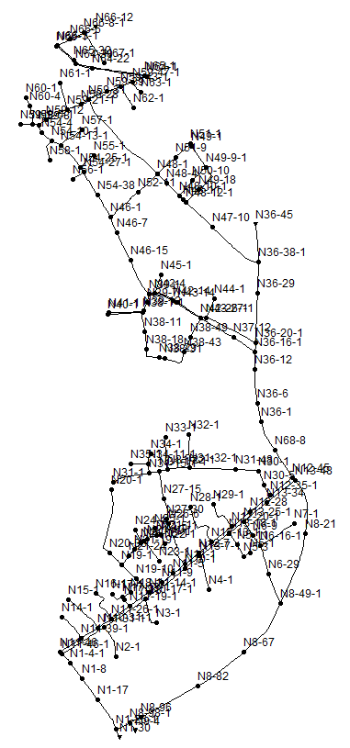

Node ids

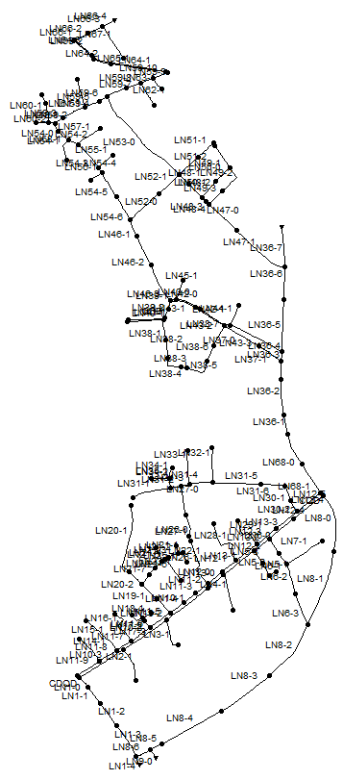

Link ids

1. Results

Vsklgjpwedcnsdlkvgjbwjf

## Appointment Scheduler

As discussed in section 5.2.1, the first step taken in understanding the Dialogflow platform involved developing an Appointment scheduler chatbot. Figure 18 shows screenshots of the Appointment scheduler chatbot setting an appointment for 1 March at 10 am for a Thesis update. The set appointment is shown in the Google Calendar screenshot at the bottom of the figure. The Appointment Scheduler chatbot was developed successfully allowing for the setting of the appointment at the specified date and time. If the required slot was already filled the chatbot would alert the user that the slot is already taken allowing the user to set another appointment on a free slot.

|  |  |
| --- | --- |
|  |  |
|  | |

Figure 18: Appointment Scheduling Chatbot Screenshots

The Chatbot was also successfully linked to a FAQ page which in this case answered questions on the Corona Virus. A sample of such answers is displayed in Figure 19. While the chatbot responded accurately to questions that were on the FAQ page it, however, reverted to the Fallback intent if there was any spelling mistake or if the question was phrased as *‘What is Corona?’* instead of ‘*’What is Covid?*’. This was due to the fact that there were no training phrases and therefore machine learning algorithms implemented on the questions on the FAQ page and as such the results obtained were strictly for the questions asked in the exact words on the FAQ page. Nothing was done to improve this as this was not directly part of the research. The knowledge gained was however paramount in the development of the SWMMBot application outlined in the following section.

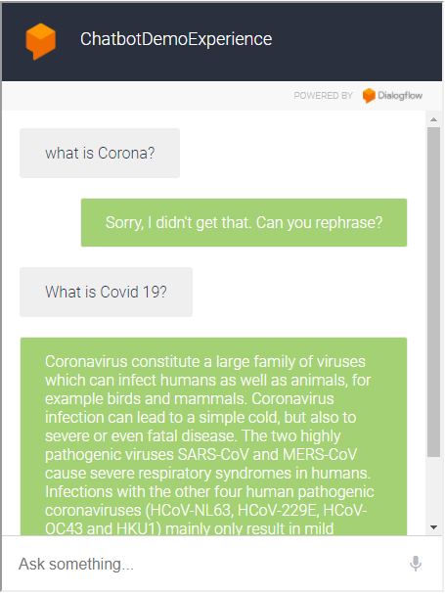

Figure 19:FAQ Integration in Scheduler Chatbot

## SWMMBot

### Dialogflow

The

### Data extraction from EPA SWMM

Python code here

Plots of python extraction vs SWMM Plots

Vsklgjpwedcnsdlkvgjbwjf

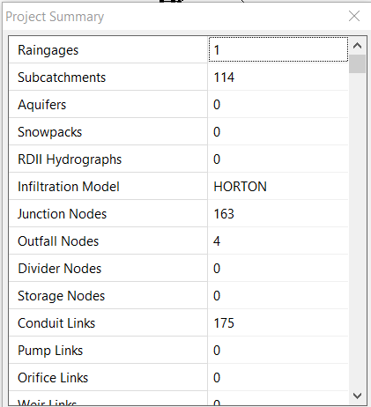

Numbe rof pipes, nodes, subcatchments

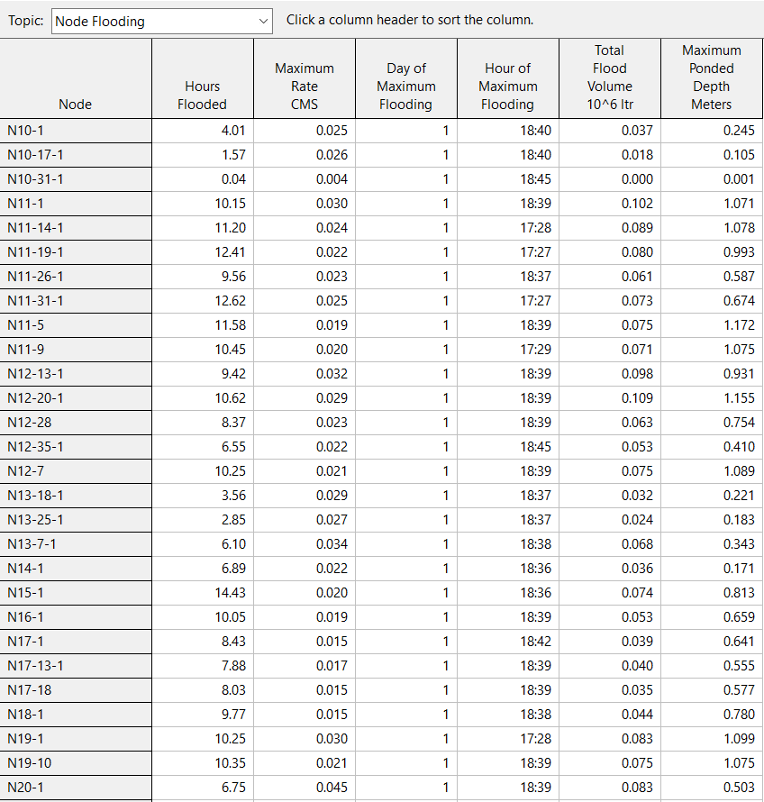

Node flooding (real)

**Extracted from SWMM using Python vs Graph from SWMM Model**

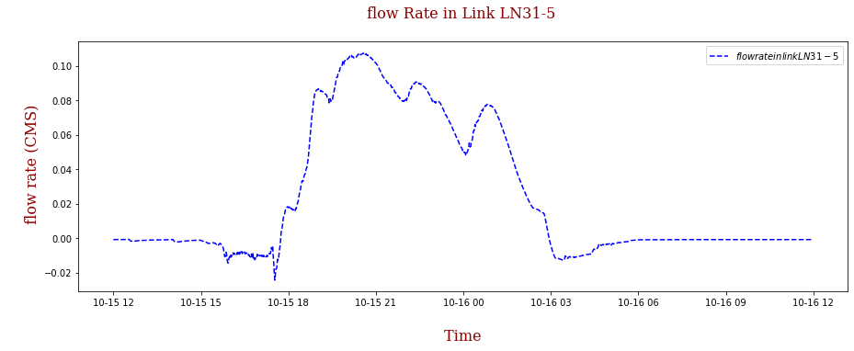

Extracted from SWMM Using Python-Flowrate for Node LN31-5

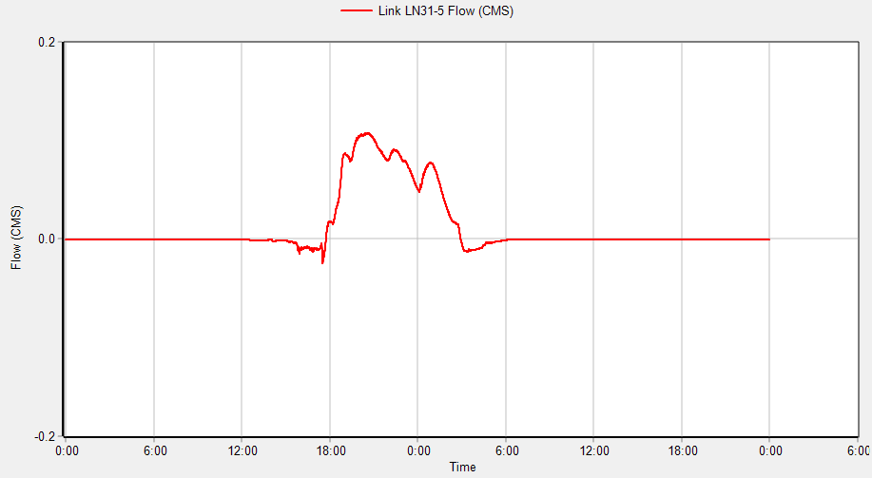

From SWMM model run-Flowrate for Node LN31-5

For model_weir_setting input file:

Put the xtraction from python here

## Web Page

dfgaead

## Implementation: Chatbot Pilot Test

sdfgaads

1. Conclusions and Recommendations

Bdifeaxnifn

## Conclusions

## Recommendations

# References

Al Rasyid MUH, Sukaridhoto S, Dzulqornain MI, Rifa’i A (2020) Integration of IoT and chatbot for aquaculture with natural language processing. Telkomnika (Telecommunication Comput Electron Control 18: 640-648

Alfonso L (2021) Web Applications for Groundwater Modelling IHE Delft Institute of Water Education, pp. 24.

AoDREM (2020) 2020 Global Natural Disaster Assessment Report Academy of Disaster Reduction and Emergency Management, Ministry of Emergency Management - Ministry of Education, National Disaster Reduction Center of China, Ministry of Emergency Management, International Federation of Red Cross and Red Crescent Societies

Boné J, Ferreira JC, Ribeiro R, Cadete G (2020) DisBot: A Portuguese Disaster Support Dynamic Knowledge Chatbot. Applied Sciences 10 DOI 10.3390/app10249082

Cahn J (2017) Chatbot: Architecture, Design and Development. Senior Thesis University of Pennsylvania

Cembrano G (2004) Optimal control of urban drainage systems. A case study. Control Engineering Practice 12: 1-9 DOI 10.1016/s0967-0661(02)00280-0

Chen SH, Jakeman AJ, Norton JP (2008) Artificial Intelligence techniques: An introduction to their use for modelling environmental systems. Mathematics and Computers in Simulation 78: 379-400 DOI 10.1016/j.matcom.2008.01.028

Cheng Y, Jiang H (2021) Customer–brand relationship in the era of artificial intelligence: understanding the role of chatbot marketing efforts. Journal of Product & Brand Management

Dahiya M (2017) A tool of conversation: Chatbot. International Journal of Computer Sciences and Engineering 5: 158-161

Deveci Topal A, Dilek Eren C, Kolburan Geçer A (2021) Chatbot application in a 5th grade science course. Education and Information Technologies 26: 6241-6265 DOI 10.1007/s10639-021-10627-8

Divya S, Indumathi V, Ishwarya S, Priyasankari M, Devi SK (2018) A self-diagnosis medical chatbot using artificial intelligence. Journal of Web Development and Web Designing 3: 1-7

Do H (2021) Do Lo, Yen Nghia, Ha Dong, Ha Noi Study Area Description. In: Ncube S (ed), Study Area Description (Do Lo, Yen Nghia, Ha Dong, Ha Noi) edn, Not published.

Eckart K, McPhee Z, Bolisetti T (2018) Multiobjective optimization of low impact development stormwater controls. Journal of Hydrology 562: 564-576 DOI 10.1016/j.jhydrol.2018.04.068

Ellis B, Viavattene C, Revitt M, Peters C, Seiker H (2009) A Modelling Approach to Support the Management of Flood and Pollution Risks for Extreme Events in Urban Stormwater Drainage Systems

García L, Barreiro-Gomez J, Escobar E, Téllez D, Quijano N, Ocampo-Martinez C (2015) Modeling and real-time control of urban drainage systems: A review. Advances in Water Resources 85: 120-132 DOI 10.1016/j.advwatres.2015.08.007

Ghosh SGD (2019) Natural Language Processing Fundamentals : Build Intelligent Applications That Can Interpret the Human Language to Deliver Impactful Results Packt Publishing Ltd, Birmingham

Gironás J, Roesner LA, Rossman LA, Davis J (2010) A new applications manual for the Storm Water Management Model (SWMM). Environmental Modelling & Software 25: 813-814 DOI 10.1016/j.envsoft.2009.11.009

Google (2021) Dialogflow Documentation.

Groen ET, Jacobs C (2012) Risk Mapping Vietnam:Sector Disaster Risk Reduction & Emergency Aid Cordaid.

IDMC (2019) Global Report on Internal Displacement Internal Displacement Monitoring Centre.

IPCC (2021) Summary for Policymakers. In: Climate Change 2021: The Physical Science Basis. Contribution of Working Group I to the Sixth Assessment Report of the Intergovernmental Panel on Climate Change. In: [Masson-Delmotte V, P. Zhai, A. Pirani, S. L. Connors, C. Péan, S. Berger, N. Caud, Y. Chen, L. Goldfarb, M. I. Gomis, M. Huang, K. Leitzell, E. Lonnoy, J.B.R. Matthews, T. K. Maycock, T. Waterfield, O. Yelekçi, R. Yu and B. Zhou (eds.)] (ed), pp. 42.

Irvine K, Weigelhofer G, Popescu I, Pfeiffer E, Paun A, Drobot R, Gettel G, Staska B, Stanica A, Hein T, Habersack H (2016) Educating for action: Aligning skills with policies for sustainable development in the Danube river basin. Sci Total Environ 543: 765-777 DOI 10.1016/j.scitotenv.2015.09.072

Kavitha B, Murthy CR (2019) Chatbot for healthcare system using Artificial Intelligence. Int J Adv Res Ideas Innov Technol 5: 1304-1307

Kocornik-Mina A, McDermott TKJ, Michaels G, Rauch F (2020) Flooded Cities. American Economic Journal: Applied Economics 12: 35-66 DOI 10.1257/app.20170066

Integrate Chatbot with Calendar (2021) <https://github.com/sachindroid8/integratechatbotwithcalendar>. Cited 1 March 2022

Lemos MC, Bell AR, Engle NL, Formiga-Johnsson RM, Nelson DR (2010) Technical knowledge and water resources management: A comparative study of river basin councils, Brazil. Water Resources Research 46 DOI 10.1029/2009wr007949

Liddy ED (2001) Natural language processing

Mostaco GM, De Souza IRC, Campos LB, Cugnasca CE (2018) AgronomoBot: a smart answering Chatbot applied to agricultural sensor networks14th international conference on precision agriculture, pp. 1-13.

Najibi N, Devineni N (2017) Recent Trends in Frequency and Duration of Global Floods. Earth Syst Dynam: 1-40 DOI 10.5194/esd-2017-59

Nguyen MT, Sebesvari Z, Souvignet M, Bachofer F, Braun A, Garschagen M, Schinkel U, Yang LE, Nguyen LHK, Hochschild V, Assmann A, Hagenlocher M (2021) Understanding and assessing flood risk in Vietnam: Current status, persisting gaps, and future directions. Journal of Flood Risk Management 14 DOI 10.1111/jfr3.12689

Nivedhitha G, Punarselvam E, Aaghash KR, Elayabarathi M, Rahul K, Santhosh R (2021) Ai Consulting Healthcare Chatbot System Using Pattern Matching. International Journal of Scientific Research in Science and Technology: 18-22 DOI 10.32628/ijsrst2182112

Nurdiana A, Wijaya E (nd) ONLINE BOOKING CHATBOT APPLICATION FOR BLIND PEOPLE USING GOOGLE DIALOGFLOW API AND ONLINE STORE API BASED ON ANDROID

Okon AE (2021) Exploring the Use of an Artificial Intelligence Chatbot Mobile Application for Providing Early Flood Awareness. Master of Science Thesis, HE Delft Institute for Water Education

Przegalinska A, Ciechanowski L, Stroz A, Gloor P, Mazurek G (2019) In bot we trust: A new methodology of chatbot performance measures. Business Horizons 62: 785-797 DOI 10.1016/j.bushor.2019.08.005

Quah JT, Chua Y (2019) Chatbot assisted marketing in financial service industryInternational Conference on Services Computing Springer, pp. 107-114.

Ranavare SS, Kamath RS (2020) Artificial Intelligence based Chatbot for Placement Activity at College Using DialogFlow. Our Heritage Vol 68: 4806-4814

Reyes R, Garza D, Garrido L, De la Cueva V, Ramirez J (2019) Methodology for the Implementation of Virtual Assistants for Education Using Google DialogflowAdvances in Soft Computing, Lecture Notes in Computer Science:440-451.

Riaño-Briceño G, Barreiro-Gomez J, Ramirez-Jaime A, Quijano N, Ocampo-Martinez C (2016) MatSWMM – An open-source toolbox for designing real-time control of urban drainage systems. Environmental Modelling & Software 83: 143-154 DOI 10.1016/j.envsoft.2016.05.009

Salinas-Rodriguez C, Gersonius B, Zevenbergen C, Serrano D, Ashley R (2018) A semi risk-based approach for managing urban drainage systems under extreme rainfall. Water 10: 384

Schmitt TG, Thomas M, Ettrich N (2004) Analysis and modeling of flooding in urban drainage systems. Journal of Hydrology 299: 300-311 DOI 10.1016/j.jhydrol.2004.08.012

Setiawan A, Mas YSIGS, Nisa DC, Yuri MIFNM, Hilda SDY (2020) Design and Development of Chatbot Using Dialog Flowin Surya Sembada PDAM Surabaya CityInternational Joint Conference on Science and Engineering (IJCSE 2020) Atlantis Press, pp. 114-118.

Shum H-Y, He X, Li D (2018) From ELIZA to Xiaolce: Challenges and Opportunities with Social Chatbots. CoRR abs/1801.01957

Sörensen J, Persson A, Sternudd C, Aspegren H, Nilsson J, Nordström J, Jönsson K, Mottaghi M, Becker P, Pilesjö P, Larsson R, Berndtsson R, Mobini S (2016) Re-Thinking Urban Flood Management—Time for a Regime Shift. Water 8 DOI 10.3390/w8080332

Tsai M-H, Chen J, Kang S-C (2019) Ask Diana: A Keyword-Based Chatbot System for Water-Related Disaster Management. Water 11 DOI 10.3390/w11020234

# Appendices

1. Java Script Code-Appointment Scheduler

|  |
| --- |
|  |
|  |
|  |

1. Research Ethics Declaration Form

As from 2019, the IHE Delft MSc Students have to sign, submit and discuss with their mentors/supervisors a ‘Research Ethics Declaration Form’ (this form will be provided to all MSc students in October 2019). The Academic Board will specify who will endorse or approve this declaration.

The ‘Research Ethics Declaration Form’ aims to encourage all IHE Delft MSc Students to reflect on the potential ethics issues in their research proposal, and later in their thesis. **All MSc students need to read the** [Netherlands Code of Conduct for Research Integrity 2018](https://www.vsnu.nl/files/documents/Netherlands%20Code%20of%20Conduct%20for%20Research%20Integrity%202018.pdf) before signing this declaration.

